# 

# Uni-Logo

**The University of Liverpool**

The Management School

**Business Analytics and Big Data (MSc.)**

**“Uncovering Hidden Preferences in Route Planning with Data Science”**

**TB-05**

**By**

**Akash Rath**

**201682089**

**Date: 29/09/2023**

**Supervisor: Prof Tolga Bektas**

# Abstract

This research explores the nuances of last-mile delivery, focusing on Microlise's journey in enhancing their route planning amidst technological shifts. As the logistics world evolves, companies like Microlise face the challenge of balancing algorithmic solutions with human insights in route adjustments. The primary aim is to guide Microlise in this transition, ensuring it remains in step with industry advancements.

Today's digital tools are adept at analysing vast data to recommend efficient routes. Yet, human planners often refine these suggestions based on real-world experience, highlighting the importance of their "hidden preferences". Data from the study indicates that while algorithms provide foundational guidance, the touch of human experts adds the much-needed finesse, making routes more practical.

For Microlise, this digital age offers both opportunities and challenges. Algorithmic solutions promise efficiency and savings, but their integration requires careful consideration, blending traditional expertise with new technological insights.

The research findings emphasize that the role of human expertise in route planning remains crucial. This isn't just a passing trend but a reflection of the industry's core needs. The study recommends a combined approach for Microlise, integrating technological strengths with feedback from their planners, ensuring routes are both optimal and grounded in reality.

In conclusion, Microlise's path forward is clear: embrace technological advancements, value human insights, and aim for excellence in route planning solutions.

# Acknowledgement

Completing my project has been a significant and enlightening experience, filled with lessons and personal growth. This achievement was possible through the invaluable support of individuals who generously shared their expertise, time, and encouragement, ensuring I remained on track. This journey has not only enhanced my academic and professional capabilities but has also shaped my personal development.

I express my deep gratitude to my mentor, Prof Tolga Bektas, for his continuous guidance and invaluable insights that directed me throughout this journey. I also extend my appreciation to Ning Xue for the collaborative venture with Microlise, which enabled me to put my knowledge into practice.

My colleagues and dear ones played a crucial role in supporting and motivating me throughout this research. The consistent encouragement from my peers was instrumental when faced with challenging phases of the research. My family, particularly my parents, provided an unwavering foundation of love and belief in my abilities, propelling me forward through every obstacle. I take pride in the perseverance and dedication I displayed, maintaining focus on the research objectives even during challenging times. This achievement underscores the significance of collaboration and the power of collective effort in achieving ambitious objectives in both academia and life. My heartfelt thanks go out to everyone who shared their expertise and guidance on this journey.

Table of Contents

1

Abstract 2

Acknowledgement 3

Chapter 1: Introduction 6

1.1 Background 6

1.2 Problem Definition 6

1.3 Aims and Objectives 7

1.4 Challenges and Opportunities 8

Chapter 2: Literature Review 10

2.1 Introduction to Route Planning 10

2.2 Evolution of Data-Driven Route Planning in Fleet Management 10

2.3 Human Expertise and Algorithms in Route Planning 11

2.4 Microlise and its Role in Fleet Management 12

2.5 The Significance of Uncovering Hidden Preferences 13

2.6 Evolution of Last-Mile Delivery & Technological Innovations 14

2.7 Modern Route Planning Insights 14

2.8 Heuristic Approaches in Modern Route Optimization 15

2.9 Challenges and Innovations in Last-Mile Delivery 16

2.10 Future Trends and Predictions in Last-Mile Delivery 17

2.11 Comparative Analysis 17

Chapter 3: Mircolise Routing Dataset 19

3.1 Introduction 19

3.2 Dataset Overview 19

3.2.1 Route Details 19

3.2.2 Driver Assignments 20

3.2.3 Route Violations 20

3.3 Conclusion 21

Chapter 4: Research Methodology 22

4.1 Introduction 22

4.2 Data Collection 22

4.3 Preliminary Route Analysis: A Manual Investigation Approach 23

4.4 Automating Route Analysis through Encoded Folders: 28

4.5 Interpretation of Enhanced Route Analysis Output: 38

4.6 Conclusion 39

Chapter 5: Exploratory Data Analysis. 40

5.1 Data Analysis for Folder 206951 40

5.2 Data Analysis for Folder 206962 42

5.3 Data Analysis for Folder 206984 45

5.5 Data Analysis for Folder 207005 47

5.6 Data Analysis for Folder 207014 49

5.7 Data Analysis for Folder 207036 52

5.8 Data Analysis for Folder 207634 54

5.10 Advanced Analysis of Output Metrics 58

5.10.1 Statistical Summary 59

5.10.2 Data Cleaning 61

5.10.3 Exploratory Data Analysis 62

5.10.4 Principal Component Analysis 63

5.10.5 K-Means Clustering 64

5.10.6 Feature Importance Analysis 67

5.10.7 Feature Importance Analysis Using Gradient Boosting Machines (XGBoost): 70

5.10.8 Association Rule Mining 71

Chapter 6: Conclusion and Limitations 73

6.1 Conclusion: 73

6.2 Limitations: 74

6.3 Recommendations for Future Actions: 75

7.0 References 77

8.0 Appendix A- codes 82

# Chapter 1: Introduction

## Background

The transport and logistics industry are a cornerstone of modern economies, ensuring the smooth movement of goods and services. With the advent of technological developments, there has been a shift in how businesses in this sector operate (Rodrigue, 2020). Leading this transformation is Microlise, known for its innovative approach to fleet management. As the complexities and opportunities of intermodal transportation expand, the integration of technology becomes more pivotal (Crainic & Kim, 2006). Microlise offers solutions that address various operational challenges, with their route planning & optimization (P&O) tool being particularly noteworthy. This tool is engineered to provide optimal routing solutions, factoring in variables such as travel time, fuel consumption, and delivery windows (Paolo Toth & Daniele Vigo, 2014).

Yet, a pattern has emerged wherein fleet planners, despite the algorithmically generated routes, frequently make manual adjustments. This practice hints at the complex interplay of algorithmic efficiency and human expertise (Thomas H. Davenport & Julia Kirby, 2016). While algorithms are designed to optimize based on quantifiable metrics, they may at times overlook the intricate, localized knowledge that planners possess. Such knowledge, often accrued from years of experience, encompasses understanding local traffic dynamics, specific driver capabilities, or even nuances like seasonal variations affecting route accessibility. In the corporate world, balancing data-driven approaches with localized expertise has been recognized as essential for accuracy and effectiveness (Searcy & Buslovich, 2014). Therefore, while Microlise's P&O tool represents a significant stride in technologically driven route planning, the frequent manual adjustments underscore the importance of integrating experiential human insights to achieve truly optimal routing solutions.

## 1.2 Problem Definition

The transport and logistics industry has been undergoing significant transformations with the integration of technological solutions (F. He et al., 2013). Microlise's route planning & optimization (P&O) product embodies this shift, leveraging algorithmic processes to suggest routes optimized for parameters like distance, time, and fuel consumption. However, despite the computational precision of the P&O tool, fleet planners, those at on-ground operations, often adjust the algorithmically derived routes(Pérez Rivera & Mes, 2019). Such consistent deviations suggest a potential disconnect between the algorithm's recommendations and the planners' experiential insights or hidden preferences.

Delving deeper into this observation, various studies have highlighted the importance of human expertise in logistics, emphasizing that planners often consider factors beyond algorithmic comprehension, such as local traffic dynamics or specific driver-route familiarity (Pfoser et al., 2016). The essence of this research revolves around understanding and capturing these nuanced preferences.

The pivotal questions driving this research are: *What underpins these adjustments made by planners? And how can the P&O tool be enhanced to reflect both data-driven insights and human expertise for a holistic route optimization approach?* By addressing these questions, this research aims to bridge the gap between algorithmic efficiency and on-ground operational realities, aspiring to offer a more integrated and effective route planning solution (Parsa et al., 2016).

## 1.3 Aims and Objectives

The central focus of this research is to explore the manual adjustments that fleet planners make to the routes proposed by Microlise's route planning & optimization (P&O) tool. This research aims to shed light on the underlying preferences or considerations that influence these adjustments, essentially the 'hidden preferences' that the algorithm might not be currently accounting for.

**Objectives**:

1. **Analyse Manual Route Adjustments**:
   * Undertake a systematic review of the manual changes made by planners to the routes suggested by the P&O tool.
   * Determine the frequency and nature of these adjustments, highlighting any recurrent patterns or common deviations from the suggested routes.
2. **Understand Preferences**:
   * Delve into the reasons that prompt these manual adjustments, aiming to understand the balance between personal preferences, hands-on experience, and localized knowledge that might not be evident in the data.
3. **Data-Driven Analysis**:
   * Leverage advanced data analytics methodologies to examine the manual adjustments.
   * Analyse the data to identify patterns or correlations that can provide deeper insights into the decision-making processes of fleet planners.

## 1.4 Challenges and Opportunities

"In the domain of route planning, achieving a balance between algorithmic techniques and human insight has consistently presented a nuanced challenge. Historically, as (Marchet et al., 2014) pointed out, the transport and logistics industry has been reliant on the hands-on experience and knowledge of its professionals, especially when it comes to route planning. This deep-rooted reliance on human expertise brings forth the challenges and opportunities faced by Microlise's route planning & optimization (P&O) tool. It's evident that while Microlise's P&O tool brings a data-driven approach to the table, planners still find the need to make manual adjustments. This persistent behaviour highlights a pivotal challenge: there seems to be a divergence between what the algorithm perceives as optimal and the preferences of fleet planners. As stated by (Makridakis et al., 2018) , no matter how sophisticated the algorithmic tools become, they may fall short in capturing the multifaceted considerations that planners weigh. These considerations span from tangible insights, like knowledge about local terrains, to more intangible factors, such as socio-cultural nuances that influence route preferences.

Addressing this challenge, however, paves the way for an unprecedented opportunity in the industry. By deciphering and integrating these manual adjustments and inherent preferences, Microlise's P&O tool stands on the verge of a transformative shift. (Lo & Chuang, 2023) suggests that an algorithm, when refined to incorporate human insights alongside its computational capabilities, can offer a more encompassing definition of 'optimal'. Such a holistic approach could resonate better with drivers, leading to increased route adherence, which in turn could drive down operational costs and elevate overall efficiency. In summary, while the task of melding human expertise with Microlise's algorithmic solutions presents hurdles, overcoming them has the potential to set a new benchmark in fleet management. The vision is clear, a route planning solution that synergizes the precision of algorithms with the nuances of human judgment (A. He et al., 2010).

# 

# Chapter 2: Literature Review

## 2.1 Introduction to Route Planning

Over the years, the transport and logistics sector has witnessed significant research developments, particularly in the domain of route planning. Early discussions in this field, notably by (Cook et al., 2011), revolved around the Traveling Salesman Problem (TSP). The TSP, while foundational, effectively highlights the intricacies of determining an efficient route, ensuring each destination is visited only once. However, as (Jan K. Lenstra & H. G. Rinnooy Kan, 2006) articulated, the problem’s complexity surges with the addition of more destinations, presenting increasing challenges for businesses, especially as they expand their operations.

In the age of globalization, the dynamics of route planning have further evolved. Modern supply chains, characterized by sprawling networks connecting suppliers, distributors, and retailers, have necessitated advanced route planning methodologies. (Crainic & Laporte, 1997) emphasized that contemporary route planning extends beyond merely minimizing distances. It now encompasses a broad spectrum of considerations, from optimizing fuel consumption to adhering to specific delivery timeframes and managing vehicle load capacities.

Microlise, as an emerging leader in this domain, has been instrumental in offering innovative solutions to address these challenges. They have harnessed cutting-edge technologies, providing businesses with tools that not only suggest efficient routes but also dynamically adapt to real-world variables such as traffic conditions and inclement weather.

A pivotal advancement in this field has been the integration of Geographic Information Systems (GIS) into route planning mechanisms.(Miller et al., 2001) explored how GIS provides planners with a comprehensive overview of routes, enabling them to pinpoint potential issues and evaluate alternate paths. (Bertsimas & van Ryzin, 1991) postulated, algorithms, regardless of their sophistication, might occasionally miss the nuanced knowledge inherent to seasoned fleet planners.

## 2.2 Evolution of Data-Driven Route Planning in Fleet Management

The evolution of fleet management practices has been profoundly influenced by the onset of big data and the emergence of computational techniques. In the foundational stages, the industry was anchored in heuristic methods, with decisions predominantly based on experiential knowledge (Clarke & Wright, 1964). However, the increasing intricacy of modern transportation landscapes, coupled with multifarious variables like dynamic traffic conditions and unpredictable weather shifts, necessitated a more sophisticated approach.

Microlise has been at the forefront of this transformation. By capitalizing on technological advancements, they have pioneered data-driven solutions that are reshaping fleet management. Microlise's telematics capture an array of real-time vehicle data, from precise location to engine diagnostics, which underpins their route planning & optimization (P&O) algorithms (Williams, 2019). This real-time data acquisition, combined with historical data analysis, empowers their P&O tool to make dynamic route suggestions, foreseeing potential challenges like congestion points or risky zones (Jun et al., 2011). Data-driven route optimization, by promoting fuel efficiency, directly contributes to reduced carbon emissions, resonating with global environmental goals (Barth & Boriboonsomsin, 2008).

## 2.3 Human Expertise and Algorithms in Route Planning

The convergence of human expertise and advanced algorithms in fleet management has emerged as a crucial domain in modern logistics. Historically, fleet management was a deeply rooted in human judgment, with decisions made out of experience and accumulated knowledge. Yet, with the digital revolution, a surge of algorithmic tools designed to aid in route planning has shifted the dynamics of the industry.

Microlise stands at the forefront of this transformation, embodying the intricate balance between technology and human intuition. Their Route Planning & Optimization (P&O) tool exemplifies this blend. It employs advanced algorithms that sift through vast data streams – from real-time traffic conditions to intricate vehicle diagnostics – proposing routes that promise efficiency in terms of time, fuel, and operational costs. Yet, what sets Microlise apart is their recognition of the inherent value of human expertise (Delling et al., 2009). Their systems, while rich in data-driven insights, are flexible by design, allowing fleet planners to adjust algorithmic suggestions based on ground realities. This ensures that routes, while optimized on paper, are also rooted in the practicalities of the transportation world.

The domain's complexity is amplified when one considers the myriad variables that seasoned planners’ factor into their decisions. Local events, transient roadworks, or even specific driver preferences can profoundly influence route choices. These nuances, although sometimes elusive to algorithmic processes, are second nature to experienced planners, highlighting the limitations of a purely data-driven approach (Psaraftis et al., 2016).

Furthermore, the realm of fleet management is not solely about route optimization. Considerations about safety, vehicle health, and driver behaviour, among others, play a crucial role. Microlise's Driver Performance Management (DPM) employs data to offer feedback on driving patterns, it's also cognizant of individual driver nuances, ensuring feedback remains contextual (van Lint et al., 2008).

The field of fleet management, while evolving rapidly, presents inherent challenges. Algorithms, with their computational rigor, can produce routes that are optimal from a data perspective. However, devoid of human intervention, these routes might lack practical feasibility or overlook nuanced variables (Bräysy & Gendreau, 2005). Conversely, an over-reliance on human expertise without the support of data-driven algorithms may introduce potential inefficiencies, given the intricate nature of contemporary transportation systems. The central challenge, underscored by recent studies, lies in the development of systems that integrate algorithmic accuracy with the depth of human judgment, aiming for a fleet management approach that is both technologically advanced and operationally pragmatic (Berbeglia et al., 2010).

## 2.4 Microlise and its Role in Fleet Management

Microlise stands as a key figure in fleet management solutions, renowned for its comprehensive product suite that includes real-time vehicle tracking and advanced route planning (P&O). These tools are more than just technological innovations; they serve as strategic instruments, enabling businesses to streamline fleet management (Crainic & Laporte, 1997). One of the primary offerings of Microlise is its real-time vehicle tracking system. As (Dablanc, 2007) , emphasized, such systems are vital in today's fleet management, providing immediate updates on vehicle locations and activities, assisting fleet managers in decision-making. Microlise's tracking system stands out due to its accuracy and user-friendly interface, making it a preferred choice for many enterprises(Ambrosini & Bowman, 2001).

The company's advancements in Route Planning and Optimization (P&O) challenge traditional, often inefficient, manual planning methods (Laporte, 1992). By utilizing sophisticated algorithms and data-driven insights, Microlise's P&O solutions suggest optimal routes that account for various external factors, resulting in savings and improved customer experiences (Rand, 1988), such optimization can lead to substantial fuel savings, reduced delivery times, and enhanced customer satisfaction. Driver safety enhancement is a critical concern for fleet managers. Moreover, with a focus on driver safety, Microlise incorporates features like driver monitoring and collision detection, promoting safer driving practices and reducing accident risks (Roberts & Lee, 2019 (Rodrigue et al., 2001).

From an environmental perspective, Microlise's offerings are equally impactful. With the transportation sector being a notable carbon emitter, there's an urgency for eco-friendly solutions (Church et al., 2000). Microlise's optimization tools significantly cut fuel use, thereby reducing emissions. This, coupled with its promotion of efficient driving, underscores its commitment to a sustainable future (Rodrigue, 2020). In essence, Microlise plays a crucial role in modern fleet management, addressing challenges from operational nuances to environmental concerns, poised to influence the sector's future growth (Woodburn et al., 2005).

## 2.5 The Significance of Uncovering Hidden Preferences

Fleet management has greatly benefitted from modern computational techniques like Dijkstra's algorithm (Dijkstra, 1959) and Ant Colony Optimization (Dorigo & Stützle, 2010), which excel at sifting through large datasets to suggest optimal routes. However, the intricate details, termed 'hidden preferences,' which seasoned planners account for based on their experience, are sometimes overlooked.

These 'hidden preferences' capture the subtle considerations that experienced planners take into account. While algorithms might propose an efficient route based on data, a planner, familiar with local nuances like periodic events or specific driver inclinations, might modify this recommendation. This expertise, rooted in a profound grasp of the transportation landscape, emphasizes the essence of human judgment in enhancing route planning (M. W. P. Savelsbergh, 1992).

For logistics businesses, understanding why planners modify algorithmic routes is vital. Investigating these alterations has dual benefits: it not only highlights complexities influencing route planning but also can help refine planning tools. For instance, if a route segment is consistently avoided by planners even when deemed optimal by algorithms, it might signify overlooked factors like regular minor disruptions or variable traffic conditions. Unpacking such trends can guide algorithm improvements to better mirror real-world scenarios (Crainic et al., 2004).

In essence, contemporary fleet management combines algorithmic recommendations with human insights. Algorithms ensure foundational efficiency, while human expertise tailors these suggestions to real-world nuances. The aspiration for modern fleet management is to harmonize data-driven insights with hands-on experience, achieving a balanced and effective route planning strategy (Toth & Vigo, 2002).

## 2.6 Evolution of Last-Mile Delivery & Technological Innovations

The logistics landscape, crucial for global trade, has evolved notably. Central to this change is last-mile delivery, which has gained prominence due to the surge in e-commerce and the heightened expectations of timely, accurate deliveries (Morganti et al., 2014).

The Amazon Last Mile Technology Challenge exemplifies this evolution, highlighting the shift to tech-centric solutions like data analytics and route optimization (Visser et al., 2014). As consumers increasingly expect quicker deliveries, the essence of last-mile delivery pivots not just on speed, but precision, sustainability, and affordability. A blend of these factors charts the success trajectory in this domain (Hsiao & Chen, 2016).

Emerging tech tools, such as real-time tracking and predictive analytics, are shaping this change. The innovations spotlighted by the Amazon Challenge offer insights into the next phase of last-mile delivery (Agatz et al., 2011).

Microlise's offerings, especially its P&O product, are intertwined with last-mile delivery. As the sector evolves, refining routing algorithms based on planner preferences becomes essential. This project, focused on uncovering these preferences, is aligned with the industry's trajectory, ensuring Microlise's continued leadership and product efficacy.

## 2.7 Modern Route Planning Insights

The logistics realm is rapidly shifting towards data-centric strategies, especially for optimizing last-mile deliveries. This shift is evident from the Amazon Challenge, where many victors employed data analytics, machine learning, and AI for route enhancements (Goodfellow et al., 2016). While route planning once relied on experience-based heuristic methods (Bertsimas & van Ryzin, 1991), today's big data and computational prowess offer real-time, precise planning (Goodfellow et al., 2016). AI and machine learning stand out, processing and learning from data, thus refining route predictions (Bräysy & Gendreau, 2005).

For Microlise, at the helm of fleet management, there's potential in these advances. Comparing their methods with the Amazon Challenge's might spotlight enhancement areas (Tian, 2016). If Microlise leans towards heuristic techniques, blending in machine learning could be game-changing. If they're already tech-savvy, the challenge could offer refinement or validation insights (Verdonck et al., 2016).

In essence, the growing emphasis on data-driven insights in route planning signifies the industry's progression. Microlise, by aligning with these trends, ensures its solutions stay adept, meeting the nuanced needs of last-mile deliveries (Ehmke & Campbell, 2014).

## 2.8 Heuristic Approaches in Modern Route Optimization

Route optimization, a cornerstone of the logistics and transportation industry, has historically been influenced by both algorithmic computations and heuristic methodologies. These two approaches, although seemingly disparate, have found harmony in modern applications, paving the way for more efficient and adaptive route planning solutions (Laporte, 1992).

Heuristics, essentially problem-solving strategies, or shortcuts have been employed for decades due to their capacity to generate satisfactory solutions in relatively shorter time frames. The seminal Clarke-Wright savings heuristic is a classic example of how heuristics have been successfully applied to solve the vehicle routing problem (Clarke & Wright, 1964). These heuristic methodologies are based on rules-of-thumb, past experiences, or intuitive judgments.

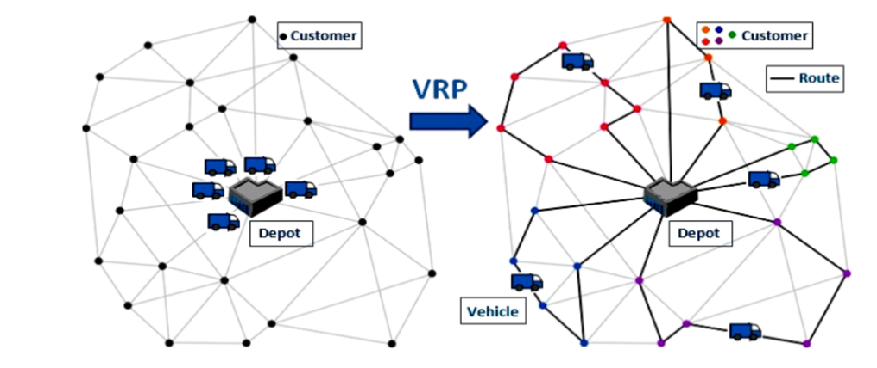

**Figure 1: Classical Vehicle Routing Problem** (Gupta & Saini, 2017)

In contrast, algorithmic approaches, rooted in mathematical and computational rigor, offer deterministic solutions based on predefined rules (Paolo Toth & Daniele Vigo, 2014). However, real-world scenarios, characterized by dynamic variables and uncertainties, can make these algorithms less efficient or adaptable in certain contexts (Cordeau et al., 2007). The combination of these two approaches has proven essential in addressing the vast array of problems and scenarios found in the field of route optimization (Braekers et al., 2016).

## 2.9 Challenges and Innovations in Last-Mile Delivery

Last-mile delivery intricacies are pivotal in both academia and industry due to their influence on customer satisfaction and operational efficiency (Gevaers et al., 2014). The Amazon Challenge accentuated the challenges of purely algorithmic transportation planning and emphasized the indispensable role of human expertise in navigating real-world complexities. Urban congestion and unpredictable traffic, as highlighted by (Visser et al., 2014b), are major barriers to timely deliveries, further complicated by dispersed urban delivery points, leading to inefficiencies and raised costs (M. Savelsbergh & Van Woensel, 2016).

With rising environmental concerns, companies are tasked with optimizing delivery efficiency while also reducing their carbon footprint, necessitating advanced algorithms and sustainable practices (Johansson et al., 2017). Amplified by e-commerce growth, modern consumers demand not just speed but also delivery precision (Agatz et al., 2012).

The Amazon Challenge showcased innovative solutions, with winners blending data analytics, heuristics, and technology to enhance last-mile deliveries. Machine learning's potential to predict and adapt to traffic patterns signifies a notable advancement in tackling urban challenges (Ehmke & Campbell, 2014). Furthermore, solutions emphasizing sustainability, such as those integrating electric vehicles or prioritizing eco-friendly routes, align with the industry's shift towards greener operations (Van Duin et al., 2013). These innovations not only address environmental concerns but also cater to the growing consumer demand for sustainable practices.

For Microlise, the Amazon Challenge provides a roadmap. By assessing showcased innovations, Microlise can discern potential strategies to adopt or adapt, potentially benefiting from a combined approach of data-driven algorithms and human insights to tackle the complexities of last-mile deliver (Van Duin et al., 2013).

## 2.10 Future Trends and Predictions in Last-Mile Delivery

The last-mile delivery landscape is swiftly evolving due to technological breakthroughs and shifting customer demands. Insights from the Amazon Last Mile Challenge offer glimpses into future trends. Data-driven decision-making is at the forefront, with a shift from static routes to dynamic ones that adjust based on real-time data, such as traffic or weather (Boyer et al., 2009). This change underscores the importance for companies like Microlise to bolster their data integration and analytical capabilities.

Environmental concerns are also reshaping the sector. The growing emphasis on eco-friendly solutions sees a rise in electric vehicles in logistics, highlighting the need for solutions that minimize ecological impacts (Wang et al., 2016).

Innovation continues with the advent of autonomous vehicles and drones, offering potential efficiency boosts, though they come with regulatory and technical hurdles (Viu-Roig & Alvarez-Palau, 2020). For Microlise, adapting to these innovations, be it through technological integration or advanced algorithm development, is vital to remain a frontrunner. In essence, the future of last-mile delivery leans towards data-driven, green, and possibly automated solutions, and Microlise's adaptability will be instrumental for its continued leadership (Mckinnon, 2007).

## 2.11 Comparative Analysis

Comparing Microlise's solutions with the innovations presented by the Amazon Challenge winners offers invaluable insights into the company's positioning in the ever-evolving logistics landscape. One of the evident strengths of the Amazon Challenge winners was their innovative use of technology. According to (Alotaibi et al., 2020) ,embracing novel technological solutions is imperative for companies aiming to stay competitive in the logistics sector. The winners showcased solutions that melded traditional route planning wisdom with modern algorithmic prowess. Microlise, in its endeavour’s, would benefit from a similar blend, ensuring that its solutions are both rooted in industry knowledge and forward-looking in terms of technological integration.

Another area of comparison is adaptability. The challenge winners demonstrated solutions that were flexible, capable of adjusting to varying scenarios and challenges. This adaptability, as noted by (Zhang et al., 2022) , is crucial in the dynamic world of last-mile delivery, where a myriad of unforeseen challenges can arise. Microlise's ability to develop and deploy adaptable solutions, which can dynamically adjust based on real-world conditions, will be a significant determinant of its success. Adaptability, as displayed by the Challenge winners, is pivotal given the unpredictable nature of last-mile delivery (Ehmke & Campbell, 2014).The capability to swiftly adjust to unforeseen challenges or dynamic conditions will be essential for Microlise's future success.

A comparative analysis indicates that Microlise would benefit from incorporating similar user-centric considerations into its solutions (Durach et al., 2017). In closing, a comparative analysis underscores the importance of technological innovation, adaptability, and user experience in last-mile delivery solutions. Microlise's strategies and developments in these areas will shape its competitive positioning in the market (de Koster et al., 2007).

# Chapter 3: Mircolise Routing Dataset

## 3.1 Introduction

Logistics involves complex decision-making, especially when planning delivery routes. The Dissertation Project Dataset, provided by Microlise, captures this complexity by detailing manual adjustments made by planners to routes generated by optimization algorithms.

While Microlise's Planning & Optimization (P&O) product is designed to produce efficient routes using advanced algorithms, planners often adjust based on their experience and understanding of real-world challenges. These adjustments, meticulously documented in the dataset, offer insights into the planners' preferences and strategies.

The Dissertation Project Dataset aims to highlight the interplay between algorithmic route planning and the practical knowledge of planners. Through this dataset, we can better understand the intricacies of route planning and the value of human expertise in the process.

## 3.2 Dataset Overview

The Microlise dataset provides a comprehensive look into logistics and route planning. It captures both algorithmically determined routes and the manual adjustments made by planners, presenting a full picture of the route decision-making process.

### 3.2.1 Route Details

The Route Details section is the primary segment of the dataset, documenting each individual route. Each route in this section has a unique identifier, ensuring clarity and distinction between routes. Furthermore, the dataset offers geographical insights, mapping out each location. Delving into the order specifications, one encounters metrics such as load weight, load quantity, and load volume, giving insights into each delivery. Moreover, the dataset also provides insights into returns. It captures essential scheduling metrics to ensure timely deliveries. The dataset also logs intervals, ensuring a balance between efficiency and driver welfare.

### 3.2.2 Driver Assignments

The "Driver Assignments" section of the dataset provides insights into how drivers are assigned to specific routes. Every driver assignment is marked with a unique identifier, ensuring clear distinction and avoiding confusion. This section captures important timing details, highlighting when a driver starts and finishes a route.

Additionally, the dataset gives a clearer picture of a driver's daily schedule. It outlines times when a driver is available and times when they are not, offering insight into the practical constraints of their workday. This detailed information helps us understand the thought process behind each assignment.

In conclusion, the "Driver Assignments" section offers a thorough overview of driver scheduling. It provides valuable details on how routes are allocated to drivers, ensuring the efficient operation of the logistics process.

### 3.2.3 Route Violations

The "Route Violations" section captures the unexpected challenges faced during route execution. Every challenge is logged with its unique identifier, simplifying its analysis. The dataset describes the exact nature of each violation, offering clarity on what went wrong during the route. This detailed information is crucial because it provides direct feedback on the planning process. By analysing these challenges, organizations can identify areas for improvement. This knowledge helps them fine-tune their planning methods, leading to more effective and efficient operations in subsequent endeavours.

**Table 1: High-Level Description of Data Fields**

|  |  |  |
| --- | --- | --- |
| **Data Field** | **Description** | **Unit/Format** |
| Identifier | Unique identifier for the route or assignment | Alphanumeric |
| Vehicle Reference | Reference for the vehicle | Alphanumeric |
| Shift Info | Information about the shift | Numeric |
| Job Reference | Reference for the job | Alphanumeric |
| Customer Info | Information about the customer | Text |
| Location Reference | Reference for the location | Alphanumeric |
| Location Coordinates | Coordinates for the location | Float |
| Order Specifications | Details of the order | Float |
| Return Info | Information about returns | Percentage/Float |
| Time Details | Specific time-related details for delivery | Time range |
| Load Details | Information about the load | Float |
| Load Percentages | Percentages related to loading | Percentage |
| Time Metrics | Metrics related to time | Duration/Time |
| Distance Info | Information about the distance covered | Float |
| Sequence Info | Information about the sequence | Numeric |
| Assignment Identifier | Unique identifier for driver or compartment assignment | Alphanumeric |
| Timing Metrics | Metrics related to the route's timing | DateTime |
| Driver Reference | Reference for the driver | Alphanumeric |
| Starting Point | Starting location of the route | Alphanumeric |
| Permissible Timings | Allowed start timings | DateTime |
| Shift Duration Info | Information about the duration of the shift | Duration |
| Violation Identifier | Unique identifier for the route violation | Alphanumeric |
| Vehicle Info | Information about the vehicle involved in the violation | Alphanumeric |
| Violation Type | Type of violation | Numeric |
| Load Info | Details if the violation pertains to loading | Alphanumeric |

## 3.3 Conclusion

The Microlise Routing Dataset provides a detailed look into the logistics of route planning. It combines both computer-generated routes and manual adjustments from planners, illustrating the balance between technology and human expertise in logistics. The in-depth analysis of the **RouteDetails** section showcases how routes are planned, considering various factors from geographical coordinates to order specifications. This dataset also highlights the importance of efficient driver assignments, ensuring that each route is executed within the constraints of time and resources.

Meanwhile, the route violations section offers valuable insights into the challenges faced during route executions. These insights can be used to refine future route planning, making them more efficient.

# 

# Chapter 4: Research Methodology

## 4.1 Introduction

The domain of fleet operation planning is a complex interplay of algorithmic precision and human intuition. While optimization tools such as the P&O product provide well-calculated plans aimed at achieving specific user-defined objectives, such as minimizing travel distance, time, and fuel consumption, they might not always capture the nuanced decisions known to human planners. These planners, with their deep-rooted knowledge of ground realities, often introduce manual adjustments to the algorithmically generated plans. Such interventions might be influenced by several factors - from understanding local traffic and road conditions to leveraging the knowledge of a driver's familiarity with a particular area.

However, the key question that arises is: why are these adjustments made? What drives a planner to modify an optimized plan? And most importantly, can we uncover patterns or preferences behind these manual adjustments? This research aims to delve into these questions, seeking to uncover the hidden preferences and reasons behind the manual adjustments made by planners. Instead of developing new models, the focus here is on a thorough data exploratory analysis, contrasting the differences between manual adjustments and the plans proposed by the P&O product. The subsequent sections outline the methodology employed to undertake this analytical journey.

## 4.2 Data Collection

**Source and Procurement:**

The foundation of any research lies in the quality and relevance of the data it is built upon. In the case of this research, the data was procured from Microlise, a renowned organization specializing in fleet operation planning. To ensure the confidentiality and proprietary rights of the data, a Non-Disclosure Agreement (NDA) was signed. This agreement not only underlines the trust bestowed upon this research by Microlise but also emphasizes the significance and sensitivity of the information shared.

**Nature and Extent of the Data:**

The data set provided is vast and detailed. It comprises as many as 740 encoded folders. Each of these folders represents distinct route planning instances, accounting for varied routes on different days. This granularity provides a broad spectrum of scenarios, each potentially carrying unique insights about the manual adjustments and their underlying reasons.

**Preliminary Analysis:**

Upon initial examination of the dataset provided, several noteworthy observations were made. From the 740 folders, it was identified that 87 folders contained instances of route resequencing. In the context of fleet planning, resequencing refers to the manual modification of the predetermined sequence of stops or deliveries within a route. This observation is particularly significant as these 87 folders directly align with the primary research objective of understanding the rationale behind planners' manual adjustments.

As the research progresses, a systematic approach using advanced data analysis techniques will be employed to derive more comprehensive insights from this data.

## 4.3 Preliminary Route Analysis: A Manual Investigation Approach

Before diving into automated algorithms and sophisticated analytical tools, it's often beneficial to manually explore and understand the data at hand. This hands-on approach ensures that we're not only relying on automated outputs but also building an intuitive understanding of the data's characteristics and potential challenges. In the following sections, I'll share my initial steps in exploring the route solutions, giving a clear view of the resequencing process and what it means for our data.

**Analysing and Comparing Route Solutions**

In the realm of delivery or transportation management, the optimization of routes is paramount. In the given scenario, two sets of route details are being analysed: one from an original solution (**GetSolution**) and the other from a resequenced solution (**ResequenceSolution**). The major goal is to discern the differences between these solutions, specifically concerning route metrics such as distance, time, and other pertinent parameters.

**Acquiring the Data**

The analysis begins by sourcing the necessary data. This data, encompassing details about the two route solutions and the resequencing specifics, resides within three JSON files. To extract this data, the Python **json** module is used.

For instance, the original solution's data is loaded with the following approach:

python code:

*with open(get_solution_path, 'r') as file: get_solution_data = json.load(file)*

**Extraction of Key Metrics**

Upon successfully loading the data, the next step involves computing key metrics for each route. To accomplish this, dictionaries are crafted to hold metrics for each route in both the **GetSolution** and **ResequenceSolution** datasets. These metrics currently include the total distance and time for each route, but the structure allows for additional metrics if deemed necessary.

**Detecting Discrepancies**

A fundamental aspect of the analysis is identifying the variances between the original and resequenced metrics. For this purpose, a dictionary named **changes** is initialized. The strategy is simple: iterate over all the job IDs in the original solution and juxtapose them with the metrics from the resequenced solution. Any deviations in the metrics are captured and stored, thereby highlighting which specific metrics underwent alterations during the resequencing.

**Investigating Job Sequencing Alterations**

The sequence in which jobs are executed can be crucial. Thus, the code seeks to pinpoint changes in the job sequences between the original and re-sequenced solutions. By creating two dictionaries to hold the job sequences for each vehicle in both datasets, the sequences can be compared. Vehicles with altered sequences are then identified and catalogued.

**Visual Representation of Route Adjustments**

A visual representation often elucidates data more effectively. Focusing on a specific vehicle, the code extracts stop coordinates for its route from both datasets. Leveraging the **folium** library, these coordinates are used to plot the vehicle's routes on maps. This visualization aids in capturing the essence of the resequencing—displaying the original and altered routes side-by-side offers a tangible sense of the modifications.

**Timestamps: Providing Temporal Context**

Every dataset exists within a temporal context. To infuse the analysis with this context, timestamps are gleaned from the file paths of the datasets. These timestamps offer insight into when each solution was formulated and can be invaluable for understanding the broader picture.

**Collating Analysis**

Concluding the deep dive, the code compiles a broad spectrum of metrics for both datasets. This includes, but isn't limited to, the total distance, time, number of vehicles used, and potential violations. These metrics are then collated into a Data Frame—providing a consolidated view of the findings and elucidating the implications of the resequencing on the routes.

**Pseudo code:**

1. Load JSON data for GetSolution, Resequence, and ResequenceSolution.

2. Extract metrics (e.g., distance, time) for each route in GetSolution and ResequenceSolution.

3. Compare metrics between the two solutions and store any changes.

4. Identify any jobs added or removed during resequencing.

5. Create a DataFrame to represent changes in metrics and save it as a CSV.

6. Extract job sequences for each vehicle in both solutions.

7. Identify vehicles with changed job sequences.

8. For a specific vehicle (e.g., Vehicle1), extract coordinates for its stops.

9. Visualize the vehicle's routes on maps using folium and save them as HTML files.

10. Extract timestamps from the file paths of the datasets.

11. Calculate various metrics for both solutions.

12. Summarize the results in a DataFrame and print it.

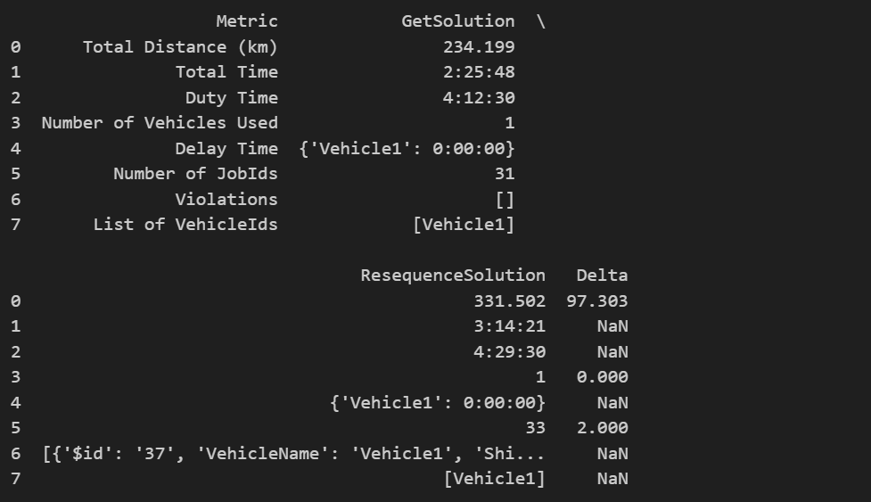

Figure 2: Summaries of Route re-sequencing

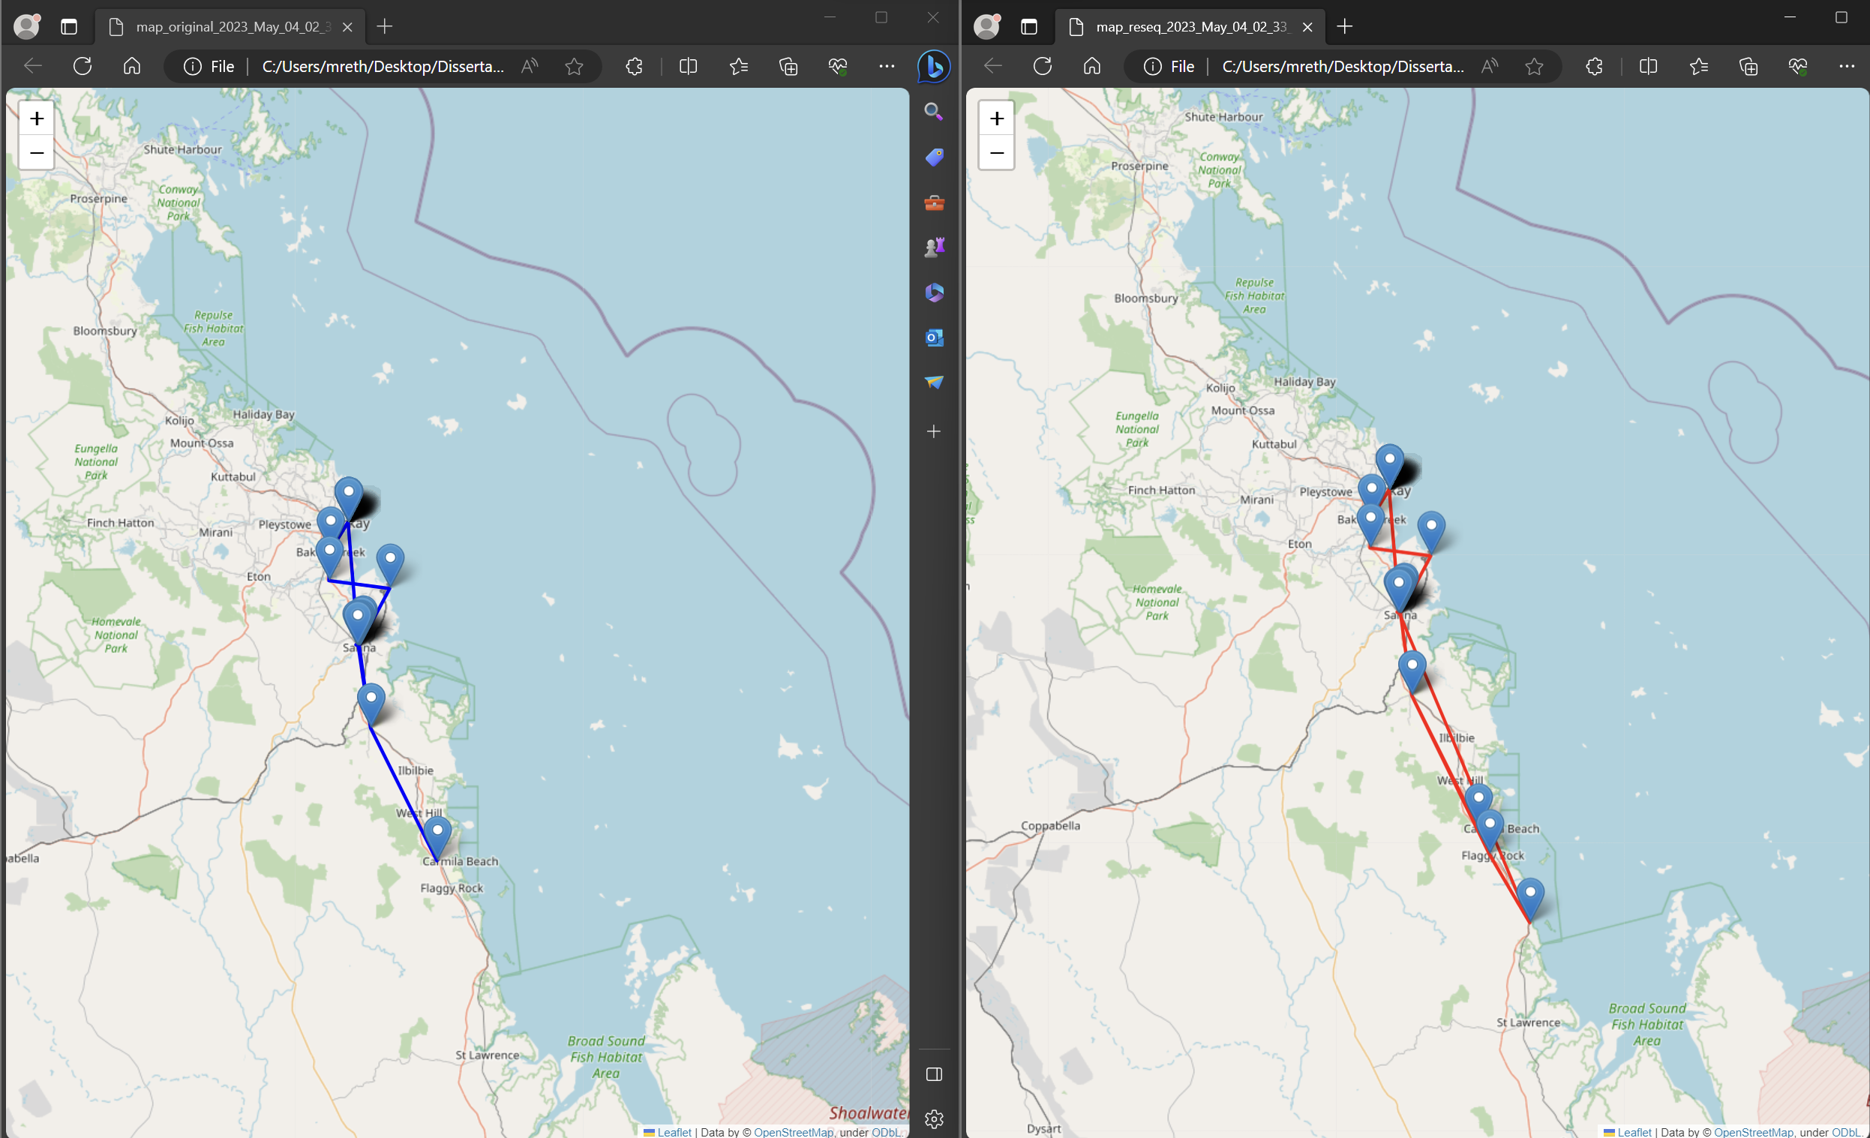

Figure 3: Original route vs Re-sequenced route

In order to understand the implications of the resequencing process on route solutions, we have closely analyzed various metrics. The table presented above offers a snapshot of the key differences between the original GetSolution and the ResequenceSolution.

At first glance, a notable observation is the increased number of stops in the ResequenceSolution. Specifically, there are two additional stops, taking the count from 31 in the GetSolution to 33 in the ResequenceSolution. This fact is further emphasized by the map visualizations, where the trajectory of the vehicle can be observed in a spatial context. By visualizing the routes, we not only get a confirmation of the extra stops but also gain insights into the path taken by the vehicle, which can be crucial in understanding the efficiency and logic of the resequencing process.

Apart from the number of stops, the table also sheds light on other important metrics. The total distance covered by the vehicle in the ResequenceSolution is 331.502 km, which is 97.303 km more than the distance covered in the GetSolution. This indicates that the re-sequenced route, while having additional stops, also spans a greater distance.

The total time metric offers insights into the duration of the journey. The re-sequenced route takes approximately 3 hours and 14 minutes, whereas the original solution is completed in about 2 hours and 25 minutes. This suggests that the additional stops in the re-sequenced solution contribute to the increased travel time.

Furthermore, both solutions utilize only one vehicle, as indicated by the 'Number of Vehicles Used' row. This means that the added stops and increased distance in the re-sequenced solution are managed by the same vehicle that was operational in the original solution.

Interestingly, the delay time for the vehicle remains unchanged in both solutions. This implies that even with the added stops and extended distance, the resequencing process hasn't introduced any additional delay. While the number of violations in the GetSolution is nil, the ResequenceSolution does seem to have some violations. This suggests that there might be certain constraints or rules that the re-sequenced solution isn't fully adhering to.

In conclusion, the table provides a comprehensive view of the changes brought about by the resequencing process. By comparing the metrics side by side, we can infer that while the re-sequenced solution introduces additional stops and covers a greater distance, it manages to do so without introducing any delay. However, the presence of violations suggests that there might be areas of improvement in ensuring the re-sequenced route adheres to all stipulated rules and constraints.

## 4.4 Automating Route Analysis through Encoded Folders:

Analysing expansive datasets, especially those distributed across multiple directories, is a complex and challenging endeavour. This complexity is magnified when dealing with datasets comprising both structured and semi-structured data. Manual examination of such voluminous route data dispersed in multiple folders is not only resource-intensive but also susceptible to inaccuracies and oversights. Given these challenges, automation emerges as a crucial solution. By leveraging automation, it becomes feasible to conduct comprehensive and precise analyses of route data, even when it is distributed across different directories. The primary objective of this automation is to extract critical insights from the dataset. Realizing this objective necessitates a combination of rigorous coding techniques and systematic methodologies.

**1. The Foundation:** RouteAnalyzer and EnhancedRouteAnalyzer Classes of our solution are two pivotal classes: RouteAnalyzer and EnhancedRouteAnalyzer. these classes play a crucial role in streamlining the process of data extraction, analysis, and representation, thereby ensuring a systematic approach to deriving insights from the data.

***Initialization: The __init__ Method:***

The __init__ method is called when a new instance of the `RouteAnalyzer` class is created. It takes in one required parameter - the `root_folder_path` which points to the directory containing the route data files.

def __init__(self, root_folder_path):

Inside the method, the first thing it does is set the `root_folder_path` as an instance variable so it can be accessed later by other methods in the class.

self.root_folder_path = root_folder_path

Next, it configures the logging so that any important information, warnings, or errors can be logged during the analysis process. This is done by getting the logger instance and setting the log level and format.

# Set up logging

self.logger = logging.getLogger(__name__)

self.logger.setLevel(logging.INFO)

log_format = '%(levelname)s:%(asctime)s:%(name)s:%(message)s'

logging.basicConfig(format=log_format, datefmt='%m/%d/%Y %I:%M:%S %p')

So, in summary, the __init__ method:

1. Accepts the root folder path as a parameter

2. Stores this path as an instance variable

3. Configures logging so important events can be tracked

This initializes the class with the essential path information and logging mechanism required before any route data can be loaded or analysed.

***Data Retrieval: Methods for Loading Data***

The load_data method in RouteAnalyzer is used to load a specific type of route data file from the root folder path. It takes two parameters:

* sub_folder - The subfolder within the root folder where the file is located.
* data_type - The type of data to load e.g., "routes", "waypoints”.

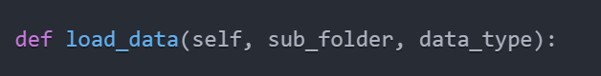

It first validates that the subfolder exists under the root path. Then it searches this folder to find files matching the data type. If exactly one match is found, it loads and returns that data.

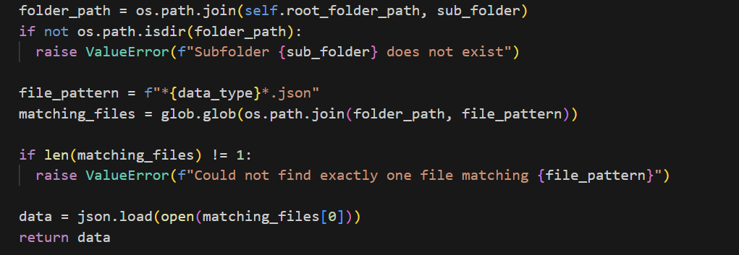

The load_json_data method simply loads and returns JSON data from a specific file path passed to it.

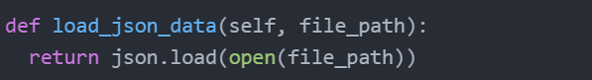

In the EnhancedRouteAnalyzer subclass, load_data_for_folder handles cases where multiple data files of the same type are present. It prompts the user to select the right one to load.

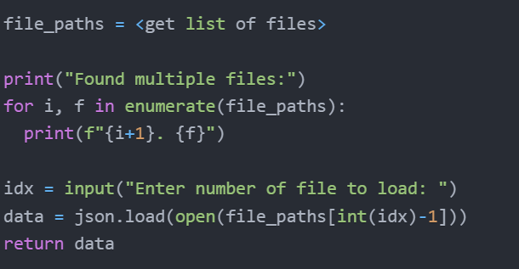

This provides robust data loading capabilities to source the route data required for analysis.

***Visualization:***

Here is a more detailed explanation of how the `visualize_route` method works:

The `visualize_route` method takes in the raw route data, which contains information like the list of latitude/longitude coordinates along the route, the order they are connected, timestamps, etc. It first creates an empty map visualization using a mapping library like Folium. Then it iterates through the coordinate pairs in the route data and adds each one as a Marker to the map.

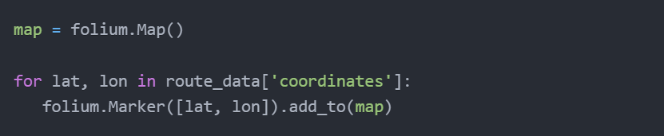

This plots all the points along the route. Next, it connects the Markers in order by drawing PolyLines between them, following the order provided in the route data.

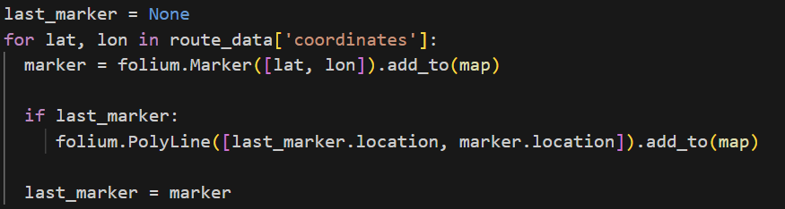

This creates a path along the route coordinates. Additional data from the route info like timestamps can be used to color code the path based on time of day, add pop-up text boxes, etc.

Finally, the map is converted to HTML that can be displayed in a Jupyter notebook or saved to an HTML file.

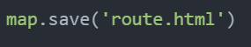

So, in summary, the method takes the raw route data, plots it on a map visualization, connects the points in order, then outputs an interactive map that can be displayed to provide a graphical overview of the route and its key information.

**Pseudo Code:**

Class RouteAnalyzer:

Function __init__(root_folder_path):

// Store root folder path

// Setup logging

Function load_data(subfolder, data_type):

// Validate subfolder exists

// Find file matching data type

// Load and return data

Function load_json_data(file_path):

// Load and return JSON data from file

Function extract_metrics(data):

// Loop through routes

// Extract distance and time metrics

// Return metrics

Function compare_metrics(original, final):

// Compare original vs final metrics

// Return changed metrics

Function visualize_route(route_data, vehicle_id):

// Get coordinates for vehicle_id

// Initialize map centered on coordinates

// Add markers for each coordinate

// Draw polyline connecting coordinates

// Return map

Class EnhancedRouteAnalyzer(Subclass of RouteAnalyzer):

Function load_data_for_folder(folder_path):

// Find GetSolution and ResequenceSolution files

// Load data for each file

// Return lists of data

Function select_data(data_list):

// If 1 file, return it

// Else prompt user to pick file or aggregate

Function visualize_combined_routes(route_data_list, colors):

// Validate input

// Initialize map from first route

// Draw polylines for each route data

Function analyze_differences(get_solution, reseq_solution):

// Extract and compare job IDs

// Print unique, relocated, and retained jobs

Function visualize_common_jobs(get_solution, reseq_solution):

// Find common jobs

// Initialize map

// Draw polylines for common jobs

// Add markers

// Return map

**2. Executing the Automation (main function):**

The main function is central to executing the automation process for route analysis. It serves as the control centre, ensuring that various components of the system work in system to analyse, compare, and visualize route data across multiple folders.

***Setup:***

At the beginning, the main function initializes logging and defines the input and output folders:

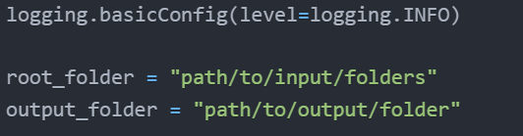

This setup ensures that the script can write log messages to track progress and issues. It also specifies where the input data folders are located and where to save output files.

***Initialize Analyzer:***

The main function creates an instance of the EnhancedRouteAnalyzer class which encapsulates all the analysis logic:

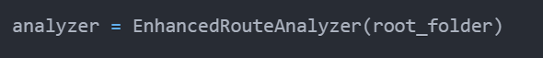

The analyzer is initialized with the root folder path defined earlier. Next, empty lists are created to accumulate data across folders. As each folder is processed, relevant data will be appended to these lists.

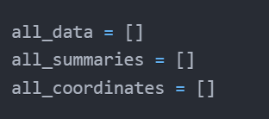

***Folder Iteration:***

To process route data distributed across multiple folders, the function iterates through each sub-folder present in the specified root directory.

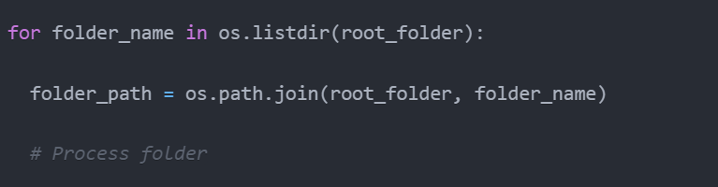

This allows the analyzer to be applied to every input data folder sequentially.

***Process Each Folder:***

Within the loop, the key steps are:

* Load folder data using analyzer.load_data_for_folder().
* Analyse differences between solutions.
* Generate and display route map visualizations.
* Extract summary metrics for the folder.
* Append summary and coordinates to consolidated lists.

***Per-folder Data Handling:***

As the function iterates through each folder, a series of operations happen:

* **Data Loading**: Using the **load_data_for_folder** method of the **analyzer**, data corresponding to the current folder is fetched. This method is also equipped to handle scenarios with multiple data files of the same type, prompting the user to select in such cases.



* **Data Analysis**: Comprehensive comparisons between various route solutions are performed. The differences, similarities, and any potential anomalies are identified during this phase.
* **Visualization**: The spatial layout and sequencing of the routes are graphically represented, providing a visual insight into the data. This visual representation is achieved using the **visualize_route** method.



* **Summary Extraction**: For each folder processed, a summary is generated. This summary encapsulates key metrics, insights, and findings from the data present in the folder.



***Data Consolidation****:*

After all folders have been processed, it's essential to consolidate the results. This ensures that a holistic view of the analysis is available, facilitating further in-depth exploration or sharing. The function achieves this by saving the consolidated data into CSV files, making it accessible for subsequent evaluations.



**Pseudo Code:**

Function main():

// Setup

Initialize logging

Define root folder path

Define output folder path

// Create analyzer instance

analyzer = EnhancedRouteAnalyzer(root_folder)

// Lists to consolidate data

all_data = []

all_summaries = []

all_coordinates = []

// Loop through each folder

for each folder in root folder:

// Load folder data

get_solution_data, reseq_solution_data = analyzer.load_data(folder)

// Analyze and compare data

analyzer.analyze_differences(get, reseq)

// Check if order changed

order_changed = analyzer.has_order_changed(get, reseq)

// Generate summary

summary_df = analyzer.generate_summary(get, reseq)

// Extract unique, relocated, retained jobs

unique_jobs, relocated_jobs, retained_jobs = analyzer.compare_data(get, reseq)

// Visualize combined routes

map = analyzer.visualize_combined_routes(get, reseq)

// Extract summary as dict

summary_dict = summary_df.to_dict()

// Get coordinates

get_coords = get_solution_coords(get)

reseq_coords = reseq_solution_coords(reseq)

// Create folder data dict

folder_data = {summary_dict, unique_jobs, relocated_jobs, etc}

// Append to consolidated lists

all_data.append(folder_data)

all_summaries.append(summary_dict)

all_coords.append({coords})

// Write consolidated data to CSVs

df = pandas.DataFrame(all_data)

df.to_csv(output_folder + '/consolidated.csv')

Below is a sample output :

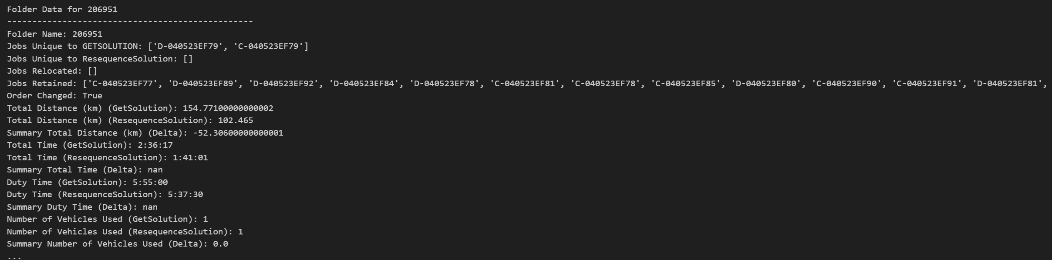

## 4.5 Interpretation of Enhanced Route Analysis Output:

The enhanced route analysis provides valuable insights into the optimization of fleet operations. One of the core aspects of this analysis is the examination of job assignments. By contrasting the original solution with the re-sequenced route, we can identify unique tasks or jobs that are either exclusive to the initial plan or have been introduced in the optimized version. This examination helps in understanding any potential tasks that were added or overlooked during the optimization process. Moreover, the movement or relocation of jobs within the route sequence can reveal significant information about the underlying logic of route reorganization. It's also noteworthy to mention that certain jobs remain consistent across both solutions, serving as a foundation for the route's stability.

Another focal point of the analysis is the sequence in which jobs are executed. Any change in this sequence can drastically influence the route's efficiency, time metrics, and adherence to specific schedules or delivery windows.

In terms of route metrics, several parameters stand out as critical indicators of operational performance. The total distance covered by the route provides implications about fuel consumption, environmental impact, and cost efficiency. Similarly, the overall time taken for route completion can shed light on driver productivity, customer satisfaction, and overall operational prowess. Other metrics, such as the duration a vehicle is operational (duty time), the number of vehicles used, any waiting or delay times, and the total number of stops, play crucial roles in understanding fleet management, resource utilization, and customer service levels. Furthermore, any deviations from established rules or constraints are highlighted through the violation metrics, emphasizing the importance of compliance in route planning. Lastly, insights into the vehicles used in routes are pivotal for effective fleet allocation and maintenance planning.

In essence, this enhanced route analysis offers a comprehensive view into the intricacies of fleet operation optimization, focusing on job assignments, sequence alterations, and critical route metrics.

## 4.6 Conclusion

The main function represents a meticulously designed process tailored to ensure comprehensive handling of route data dispersed over multiple folders. By seamlessly integrating processing, analysis, visualization, and summarization steps, it encapsulates the core tenets of automation. Through this design, the function guarantees not only efficiency and precision but also a holistic approach to route data analysis.

In conclusion, the output generated by the main function offers a comprehensive comparison between the original route plan (GetSolution) and a potentially optimized one (ResequenceSolution). By examining these metrics, decision-makers can assess the efficiency, effectiveness, and feasibility of the routes, facilitating informed choices in route planning and execution.

# 

# Chapter 5: Exploratory Data Analysis.

This section delves into the results produced by our route planning system. The primary focus is to understand the modifications made by human planners to the computer-generated routes. By contrasting the initial and revised plans, we aim to identify the key considerations that planners have in mind.

We posit that examining the human-made changes can offer insights into real-world constraints or nuances the system might have missed. Such insights could prove invaluable for refining our optimization algorithms.

Our approach begins with a close look at specific instances of adjustments and then expands to a broader perspective, aggregating data from various sources. By doing so, we hope to identify common trends and their implications for improving the automated route planning.

In essence, this research seeks to bridge the gap between algorithmic solutions and real-world applications. The subsequent sections will detail our findings and insights.

## 5.1 Data Analysis for Folder 206951

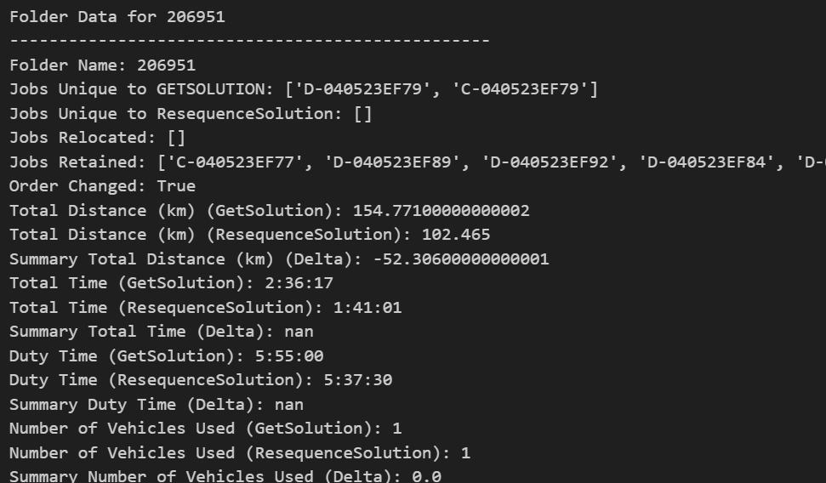

Figure 4: Summary of KPIs

**1. Job Analysis:**

* **Jobs Unique to GetSolution:** Two jobs, namely 'D-040523EF79' and 'C-040523EF79', are present in the original plan but are absent in the revised one. This could imply that these jobs were deemed unnecessary or were postponed for future consideration by the planners.
* **Jobs Retained:** A significant number of jobs were retained in the revised plan, indicating that they remain crucial to the route and were not subjected to removal or major adjustments.
* **Jobs Relocated:** Interestingly, no jobs were relocated in the ResequenceSolution. This suggests that the spatial dynamics of the route remained largely unaltered, with the emphasis perhaps being on other optimization criteria.

**3. Route Metrics Analysis:**

* **Total Distance:** There was a substantial reduction in the total distance covered in the re-sequenced route. The distance decreased from 154.77 km in the original plan to 102.47 km in the revised one, resulting in a delta of -52.31 km. This indicates a more efficient route was carved out in the ResequenceSolution, which can lead to savings in fuel and time.
* **Total Time:** The total time for the route execution also saw a decline from 2 hours 36 minutes 17 seconds in the original to 1 hour 41 minutes 1 second in the revised plan. This reduction in travel time further underscores the efficiency improvements in the re-sequenced route.
* **Duty Time:** The duty time experienced a slight reduction, indicating that the vehicle would spend less time on duty.
* **Number of Stops:** The re-sequenced plan requires one less stop than the original, which can further optimize the delivery process and potentially enhance customer satisfaction.

**4. Observations:**

* The order of jobs has changed in the ResequenceSolution, emphasizing the planners' focus on optimizing the sequence of job execution for better efficiency.
* There were no violations in both the original and re-sequenced plans, suggesting adherence to constraints and guidelines in the route planning process.
* Only a single vehicle, 'Vehicle1', was utilized in both plans, highlighting the vehicle's capacity to handle the delivery requirements.

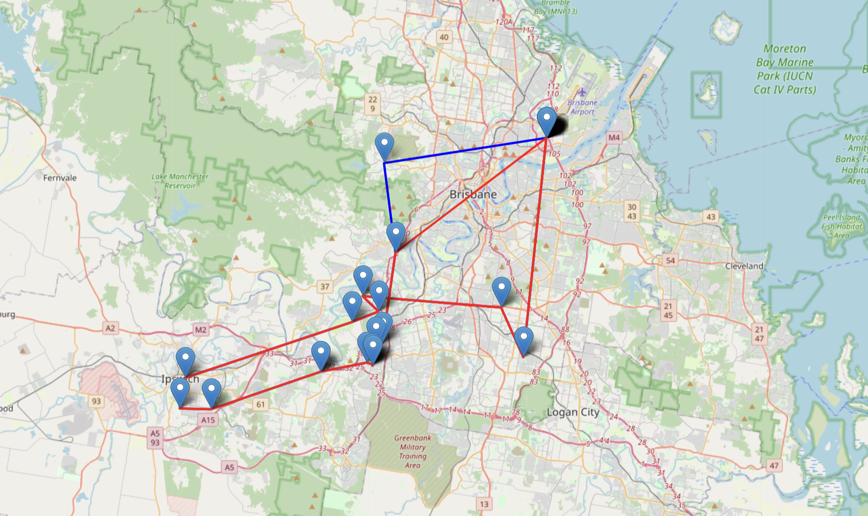

Figure 5: Route Visualisation

**5. Conclusion:**

The analysis for folder '206951' indicates a proactive effort by planners to streamline the delivery route, focusing predominantly on reducing distance and time. The absence of relocations and the retention of most jobs suggest that spatial adjustments were minimal, but the sequence optimization brought about significant improvements. The reduction in stops and the unchanged vehicle usage further reflect a balance between efficiency and resource allocation. The "ResequenceSolution" seems to be an attempt to optimize the route provided by "GetSolution". While the exact points to be visited remain mostly the same, their order and the frequency of certain points have changed. This suggests that "ResequenceSolution" is trying to find a more efficient route or sequence.

## 5.2 Data Analysis for Folder 206962

**1. Jobs Analysis:**

* **Unique to GetSolution:** No unique jobs were identified.
* **Added in ResequenceSolution:** 'D-040523RO24' and 'C-040523RO24' were added in the revised plan.
* **Jobs Retained:** Many jobs from the original plan were retained in the revised version.

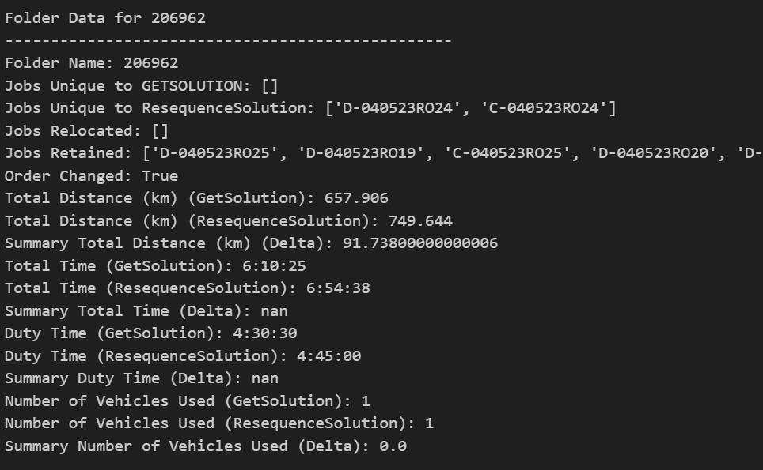

Figure 6: Summary of KPIs

**2. Route Metrics:**

* **Total Distance:** Increased by 91.738 km in the ResequenceSolution.
* **Total Time:** The revised plan took an additional 44 minutes and 13 seconds.
* **Duty Time:** Slight increase in the ResequenceSolution.
* **Number of Stops:** One additional stop in the revised plan.

**3. Key Observations:**

* Job execution sequence was altered in the ResequenceSolution.
* Violations emerged in the revised plan, indicating potential constraint breaches.
* A single vehicle, 'Vehicle1', was used in both plans.
* Both sequences begin and end at the same central point (-23.35009002685547, 150.50692749023438).
* The primary difference is the inclusion of the point (-24.215530395507812, 151.9011993408203) in the ResequenceSolution, which doesn't appear in the GetSolution.
* This can indicate an added location or a recalibration of the route in the ResequenceSolution.

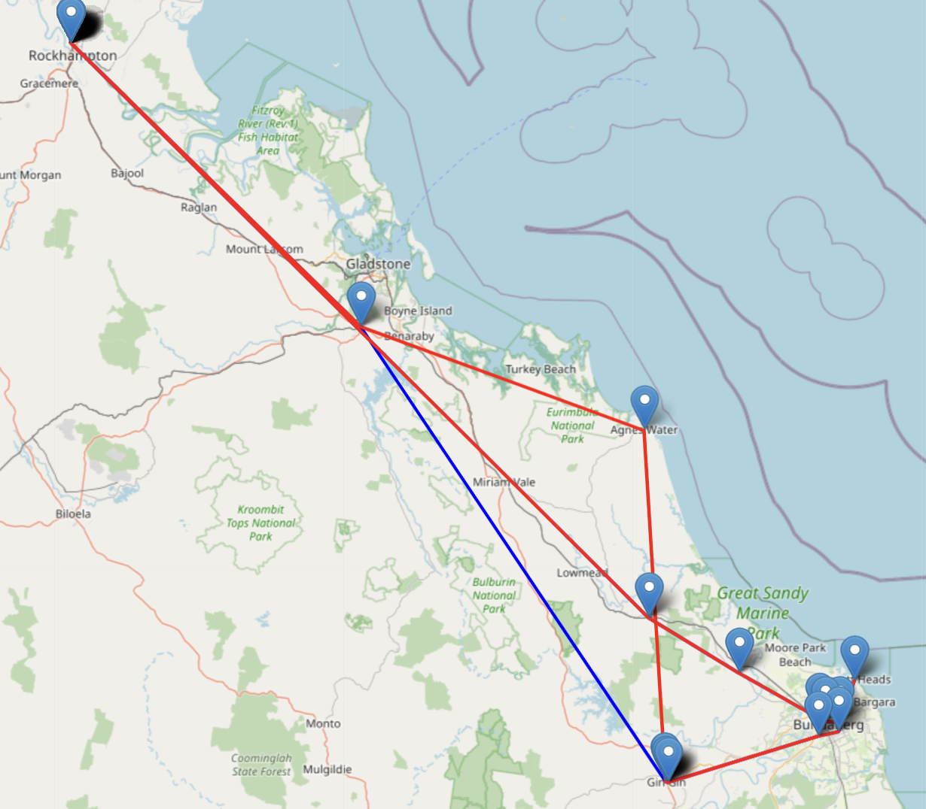

Figure 7: Route Visualisation

**4. Conclusion:**

The ResequenceSolution, while integrating new jobs, led to an elevation in distance and time metrics. While the job locations stayed consistent, their execution sequence was revised. The emergence of violations in the revised plan is a concern.

## 5.3 Data Analysis for Folder 206984

**1. Jobs Analysis:**

* **Unique to** GetSolution: No unique jobs identified.
* **Added in ResequenceSolution:** Four jobs ('D-050523MA31', 'C-050523MA31', 'D-050523MA32', 'C-050523MA32') were added in the revised plan.
* **Jobs Retained:** Majority of jobs from the original plan were kept in the revised version.

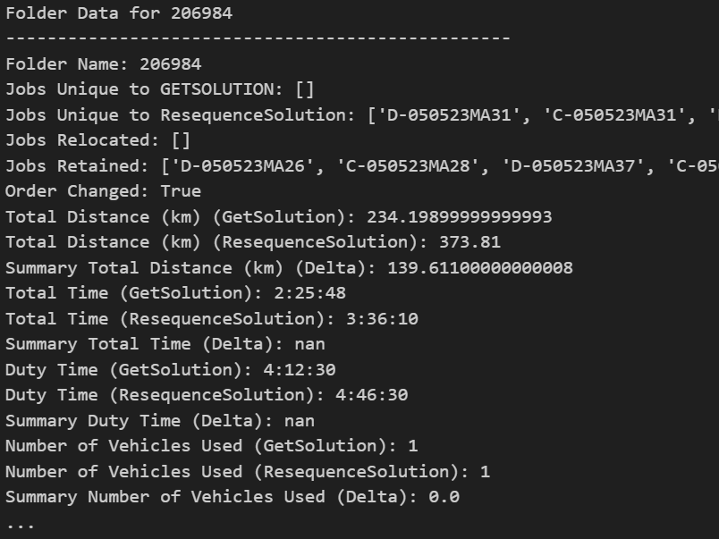

Figure 8: Summary of KPIs

**2. Route Metrics:**

* **Total Distance:** An increase of 139.611 km in the ResequenceSolution.
* **Total Time:** The revised plan took an additional 1 hour, 10 minutes, and 22 seconds.
* **Duty Time:** Increased in the ResequenceSolution.
* **Number of Stops:** Two additional stops in the revised plan.

**3. Key Observations:**

* The sequence of job execution was modified in the ResequenceSolution.
* Violations emerged in the revised plan, suggesting potential constraint breaches.
* A single vehicle, 'Vehicle1', was utilized in both plans.
* The ResequenceSolution set seems to go a bit further south than the GetSolution set, suggesting a more extended range or potentially more tasks being covered.

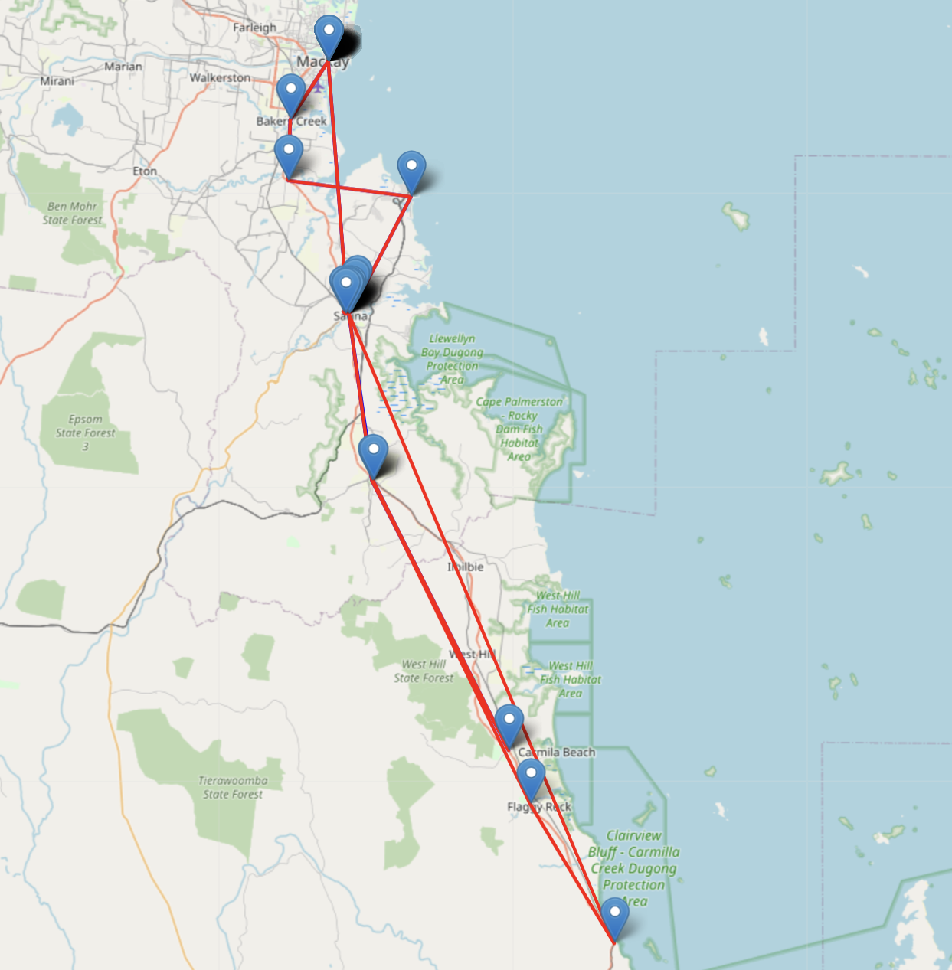

Figure 9: Route Visualisation

**4. Conclusion:**

The ResequenceSolution incorporated new jobs, resulting in increased distance and time metrics. The sequence of job execution was changed, and potential violations emerged in the revised plan.

Considering the added jobs and the changes in the route, planners might be prioritizing certain deliveries or pickups due to urgent client requests, time-sensitive shipments, or specific operational constraints. The emergence of violations in the ResequenceSolution suggests that planners may sometimes prioritize immediate logistical needs or customer preferences over system-generated optimal routes.

## 5.5 Data Analysis for Folder 207005

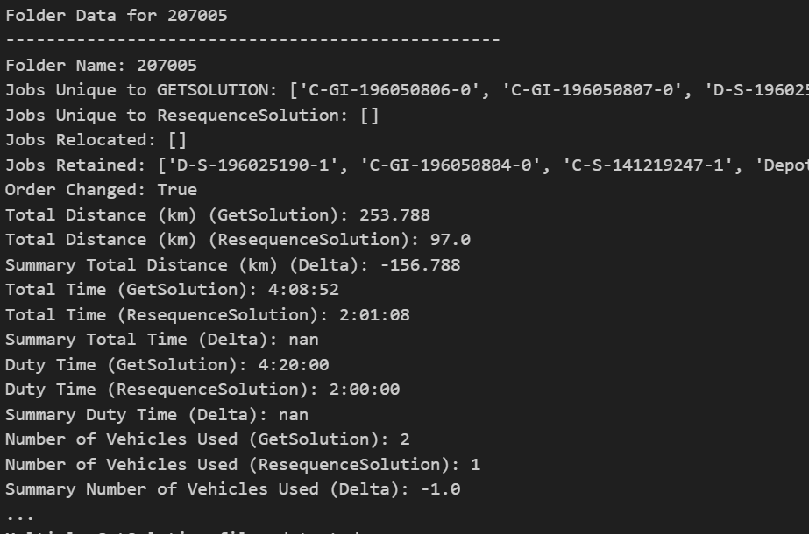

Figure 10: Summary of KPIs

**1. Jobs Analysis:**

* **Unique to GetSolution:** 14 jobs, including 'C-GI-196050806-0', 'C-GI-196050807-0', 'D-S-196025176-1', and others, were present only in the original plan.
* **Jobs Retained:** A subset of jobs from the original plan was retained in the revised version.

**2. Route Metrics:**

* **Total Distance:** A significant reduction of 156.788 km in the ResequenceSolution.
* **Total Time:** The revised plan saved 2 hours, 7 minutes, and 44 seconds.
* **Number of Vehicles:** 1 less vehicle was used in the revised plan.
* **Number of Stops:** Reduced by 7 stops in the ResequenceSolution.

**3. Key Observations:**

* The sequence of job execution was modified in the ResequenceSolution.
* No violations were reported in either plan.
* While the original plan utilized 2 vehicles ('Vehicle2' and 'Vehicle1'), the revised plan used only 'Vehicle4'.

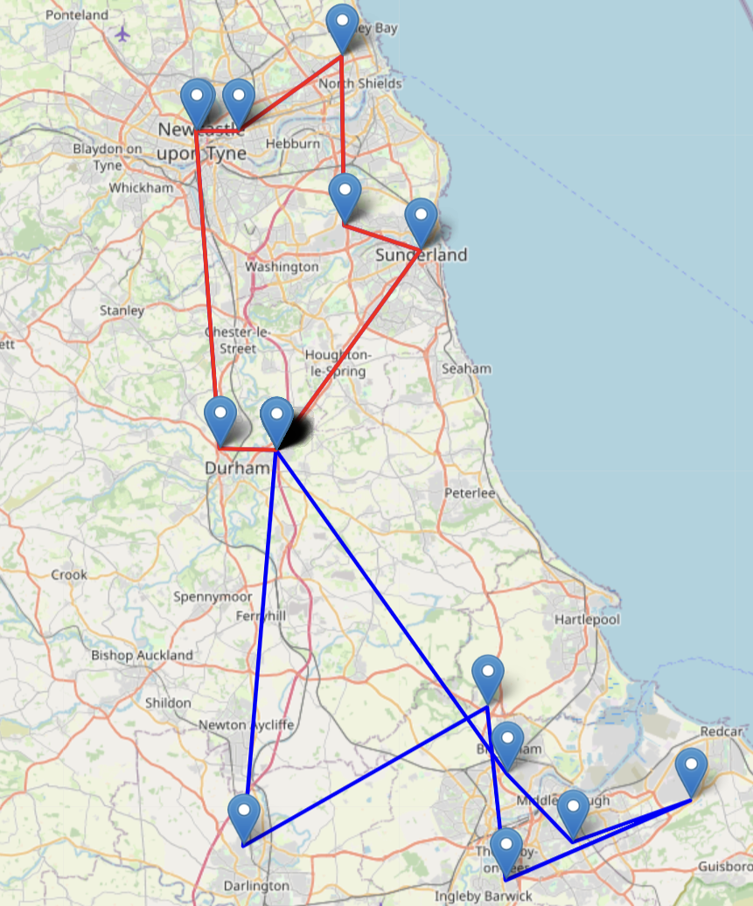

Figure 11: Route Visualisation

**4. Conclusion:**

The ResequenceSolution shows a substantial reduction in total distance, total time, and the number of stops. Most notably, 14 jobs from the original plan were excluded in the revised sequence.

These changes suggest that planners might have:

1. **Prioritized Certain Jobs:** Some jobs in the GetSolution might have been postponed or assigned to a different date or plan.
2. **Efficiency Concerns:** The significant reduction in distance and time indicates an emphasis on route optimization.
3. **Vehicle Utilization:** The reduction from 2 vehicles to 1 in the ResequenceSolution suggests better vehicle utilization or potential constraints on vehicle availability.

The revisions hint at a constant effort to improve route efficiency, possibly in response to dynamic operational needs, vehicle availability, or shifting delivery/pick-up priorities.

## 5.6 Data Analysis for Folder 207014

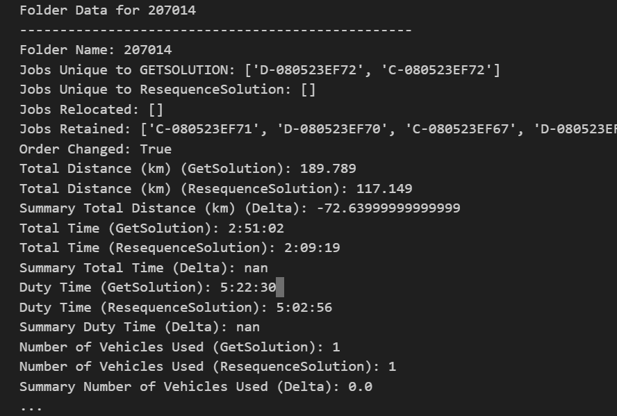

Figure 12: Summary of KPIs

**1. Jobs Analysis:**

* **Unique to GetSolution:** The jobs 'D-080523EF72' and 'C-080523EF72' were present only in the original plan.
* **Added in ResequenceSolution:** No new jobs were added in the revised plan.
* **Jobs Retained:** Most jobs from the original plan were retained in the revised sequence.

**2. Route Metrics:**

* **Total Distance:** The ResequenceSolution shows a reduction of 72.64 km.
* **Total Time:** The revised plan saved 41 minutes and 43 seconds.
* **Number of Vehicles:** No change in the number of vehicles used; both plans utilized 1 vehicle.
* **Number of Stops:** Reduced by 1 stop in the ResequenceSolution.

**3. Key Observations:**

* The sequence of job execution was altered in the ResequenceSolution.
* No violations were reported in either plan.
* Both plans utilized 'Vehicle1'.
* The ResequenceSolution does seem slightly more concise, lacking one coordinate from the GetSolution set.

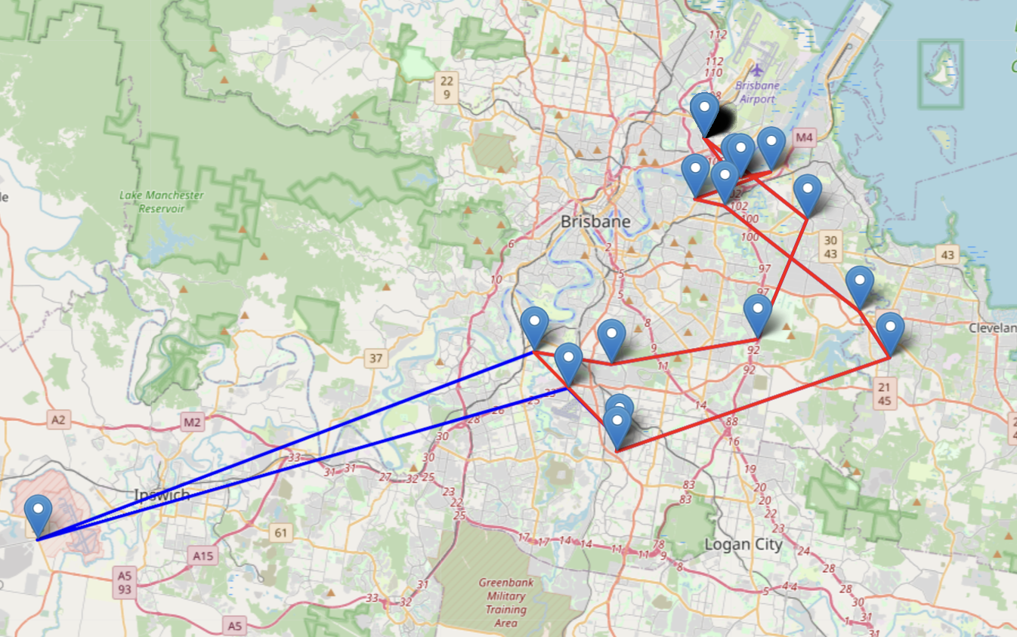

Figure 13: Route Visualisation

**4. Conclusion:**

The ResequenceSolution displays notable savings in both total distance and total time. Two jobs present in the original GetSolution were omitted in the revised sequence.

These changes suggest the following possibilities:

1. **Specific Job Prioritization:** The jobs unique to GetSolution ('D-080523EF72' and 'C-080523EF72') might have been postponed or rescheduled.
2. **Efficiency Emphasis:** The decline in distance and time suggests that the revised plan might have been optimized for efficiency, possibly considering real-time factors or constraints.
3. **Re-evaluation of Job Sequence:** The altered sequence in the ResequenceSolution might reflect a change in the order of priority or convenience based on real-time data or insights.

In essence, the planners seem to have emphasized route efficiency and real-time operational considerations in the revised ResequenceSolution.

## 5.7 Data Analysis for Folder 207036

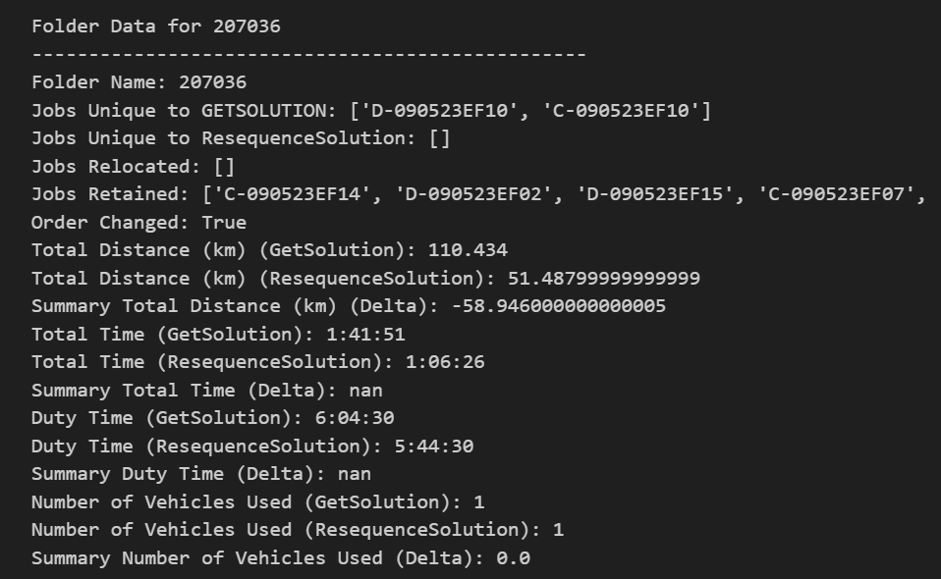

Figure 14: Summary of KPIs

**1. Jobs Analysis:**

* **Jobs Unique to GetSolution:** The jobs 'D-090523EF10' and 'C-090523EF10' were found only in the initial automated plan, indicating that these tasks were either postponed or excluded in the subsequent adjustments.
* **Added in ResequenceSolution:** No new jobs were added in the adjusted sequence.
* **Jobs Retained:** A substantial overlap of jobs between both sequences suggests the core tasks remained consistent.

**2. Route Metrics:**

* **Total Distance:** The adjusted ResequenceSolution resulted in a reduction of total distance by 58.946 km.
* **Total Time:** Adjustments lead to a time savings of 35 minutes and 25 seconds.
* **Number of Vehicles:** Both plans utilize a single vehicle, ensuring consistency in vehicle constraints and capabilities.
* **Number of Stops:** The ResequenceSolution features one less stop, indicating possible task consolidation or an adjustment based on practical considerations.

**3. Key Observations:**

* **Job Sequence Alteration:** The order of job execution has been modified in the ResequenceSolution.
* **Consistent Vehicle Utilization:** Both sequences involve 'Vehicle1', highlighting no changes in the vehicle's capacity or constraints.

**4. In-Depth Inferences:**

* **Operational Adjustments:** The decision to omit certain jobs ('D-090523EF10' and 'C-090523EF10') from the ResequenceSolution could be attributed to dynamic adjustments based on field knowledge and operational constraints.
* **Spatial Analysis:** Many jobs in both sequences share identical coordinates, suggesting that multiple tasks are likely conducted at the same locations, such as distribution centres. The adjustments might consider nuances at these sites that the initial algorithm may not capture.

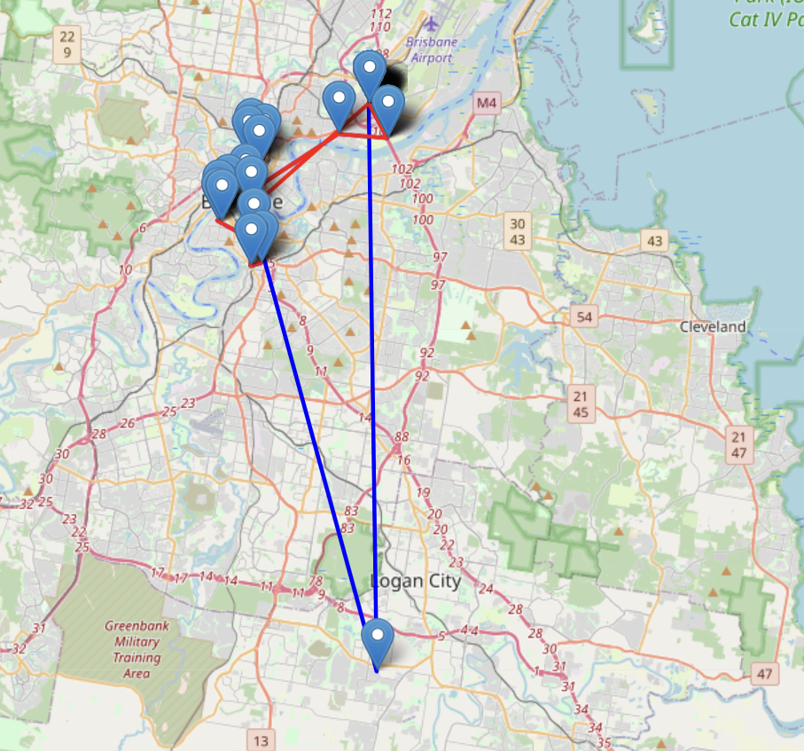

Figure 15: Route Visualisation

**5. Conclusion:**

The ResequenceSolution for Folder 207036 illustrates the balance between algorithmic solutions and manual adjustments in logistics optimization. While algorithmic solutions provide an initial framework, the refinements observed in the adjusted plan demonstrate the practical considerations that come into play during on-ground operations.

## 5.8 Data Analysis for Folder 207634

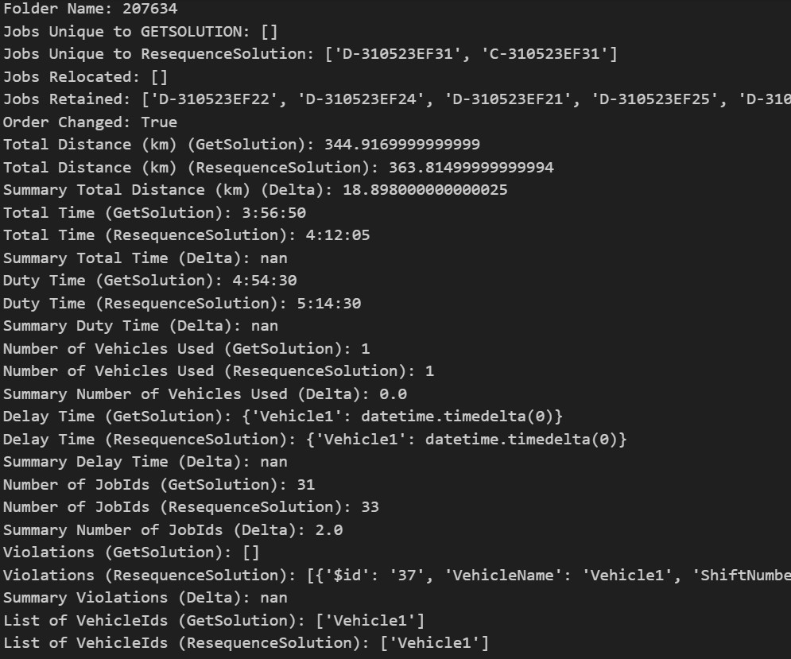

Figure 16: Summary of KPIs

**1. Jobs Analysis:**

* **Additions in ResequenceSolution:** Two jobs, 'D-310523EF31' and 'C-310523EF31', were added in the ResequenceSolution, which were not present in the initial GetSolution.
* **Consistency in Jobs:** There were no jobs unique to the GetSolution, indicating that no tasks from the initial plan were omitted in the adjustments.
* **Jobs Retained:** A substantial overlap of jobs between both sequences signifies that the foundational tasks remained consistent.

**2. Route Metrics:**

* **Total Distance:** The ResequenceSolution resulted in an increased total distance by approximately 18.898 km.
* **Total Time:** The adjusted sequence led to an additional time of 15 minutes and 15 seconds.
* **Number of Vehicles:** Both plans utilize a single vehicle, ensuring consistency in vehicle constraints and capabilities.
* **Number of Stops:** The ResequenceSolution incorporates one additional stop, which might be associated with the newly added jobs.

**3. Key Observations:**

* **Job Sequence Alteration:** The order of job execution has been modified in the ResequenceSolution.
* **Consistent Vehicle Utilization:** Both sequences involve 'Vehicle1', highlighting no changes in the vehicle's capacity or constraints.
* **Violations:** The ResequenceSolution has introduced a violation related to the 'Vehicle1'. The nature of this violation suggests a potential overextension of the vehicle's operational constraints.

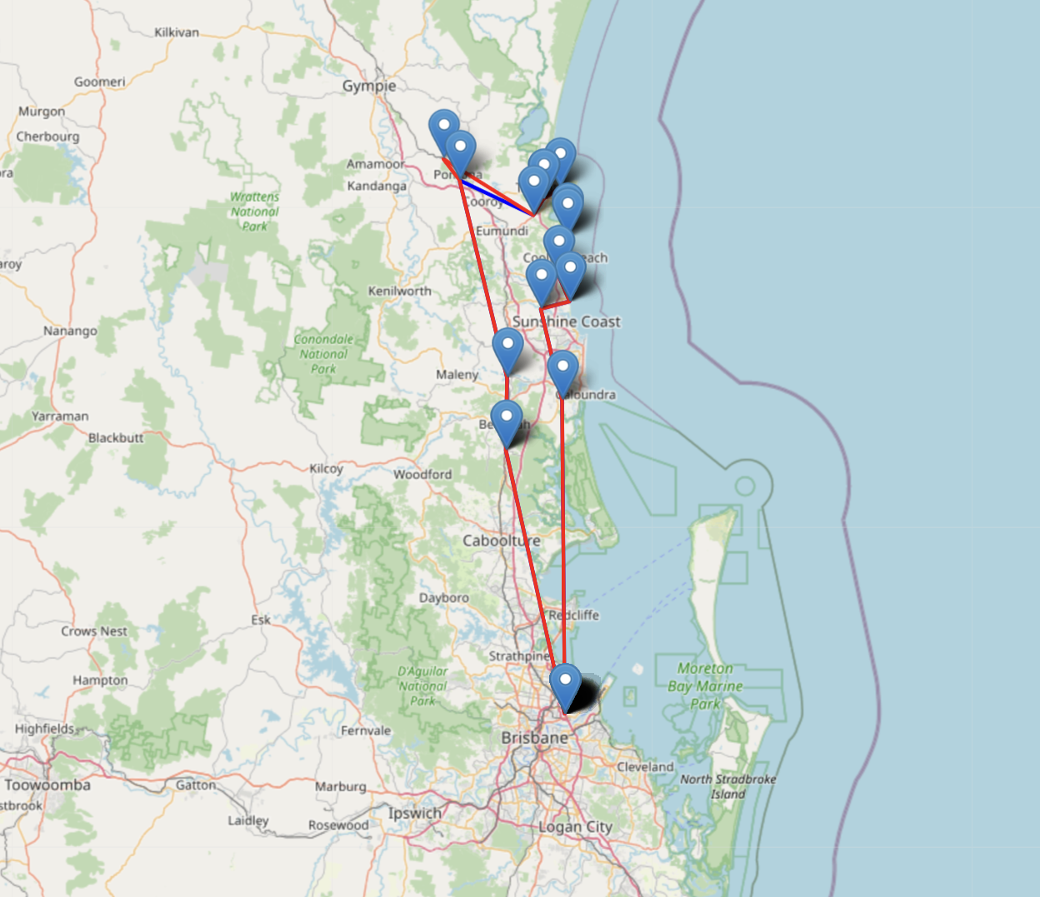

Figure 17: Route Visualisation

**4. Conclusion:**

The ResequenceSolution for Folder 207634 illustrates the intricate decision-making in logistical planning. Adjustments in the plan, including the addition of new jobs and a shift in route metrics, might have been driven by certain unobserved preferences or priorities. The introduction of a violation in the ResequenceSolution can indicate an acceptance of certain operational risks for potential gains in other areas, such as customer preferences, timely deliveries, or other logistical considerations.

***5.9 General Observations:***

1. **Job Adjustments:** Multiple folders displayed a variation in job assignments between the initial and re-sequenced plans. In some instances, jobs present in the initial solution were omitted in the re-sequenced version, and in others, new jobs were introduced. This behaviour demonstrates a dynamic approach to planning, suggesting that changes could be due to real-time operational demands, evolving customer requirements, or unforeseen logistical hurdles that the algorithm might not have initially considered.
2. **Route Metrics:** The metrics associated with routes, notably distance and time, exhibited variability across the folders. While re-sequenced plans in some folders optimized for shorter distances and reduced times, others showed an opposite trend. This fluctuation emphasizes that while achieving efficiency is a core objective, it occasionally gets balanced or even superseded by other operational or customer-centric priorities.
3. **Job Execution Sequence:** A consistent observation across most folders was the alteration in the sequence of job execution in the re-sequenced plans. This suggests planners' proactive efforts to recalibrate routes based on dynamic variables like traffic predictions, specific customer availability windows, or even vehicle constraints that might change on the day.
4. **Vehicle Utilization:** The majority of the folders-maintained consistency in vehicle usage between the initial and revised plans, indicating stable vehicle constraints. However, in cases where changes were observed, it hinted at on-the-fly fleet management decisions or changes in vehicle availability, perhaps due to maintenance, breakdowns, or other unforeseen circumstances.
5. **Violations:** The appearance or absence of violations in the re-sequenced plans is particularly insightful. It shows the continuous balancing act planners perform between operational guidelines, system constraints, and the unpredictable requirements of the real world.

***Key Insights:***

1. The relationship between algorithmic outputs and subsequent planner interventions is one of balance. The data suggests that while algorithmic solutions provide a foundational blueprint, planners integrate their expertise and ground realities to enhance these plans.

For instance, in the analysis of Folder 206951, the re-sequenced plan not only retained a significant number of jobs from the original but also managed to reduce the total distance by over 50 km, showcasing this balance between foundational jobs and route efficiency.

1. Adjustments to the job list and execution sequences across folders underscore the importance of real-time modifications.

In Folder 206962, two jobs ('D-040523RO24' and 'C-040523RO24') were added in the revised plan, indicating possible real-time requirements or changes that the initial algorithm did not or could not anticipate.

1. Spatial elements, such as the locations of jobs and the paths connecting them, emerged as pivotal components in planning. However, planners seemed to weigh these against other influential factors.

In Folder 206951, while no jobs were relocated, there was a substantial reduction in total distance, suggesting that the planners valued the spatial layout but optimized the sequence or path for greater efficiency.

1. The data reflects instances where planners potentially accepted certain operational risks to meet other pressing needs.

Folder 207634's ResequenceSolution introduced a violation related to 'Vehicle1'. This suggests that in some scenarios, planners may prioritize immediate logistical demands or specific customer requests over rigid adherence to system-generated plans.

## 5.10 Advanced Analysis of Output Metrics

In the earlier section, we began with a basic exploration of the data to identify trends in the manual changes made by planners. Moving forward, we will delve deeper into the data, especially focusing on the areas labelled "resequence" and "getsolution." Through this, we aim to connect certain measurements and reveal the hidden choices that guide planners when adjusting computer-generated routes. This will offer a clearer picture of why these changes are made.

### 5.10.1 Statistical Summary

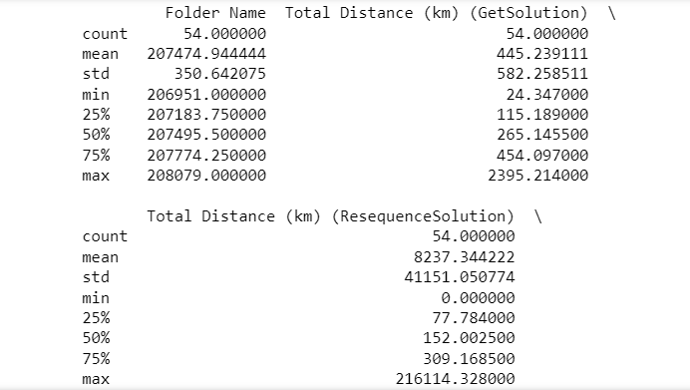

Figure 18: Statistical Summary

The average (**mean**) total distance for the **GetSolution** is approximately 445.24 km, while the average for the **ResequenceSolution** is vastly larger at approximately 8237.34 km. However, this could be skewed due to some extremely large values, as indicated by the standard deviation and the max value.

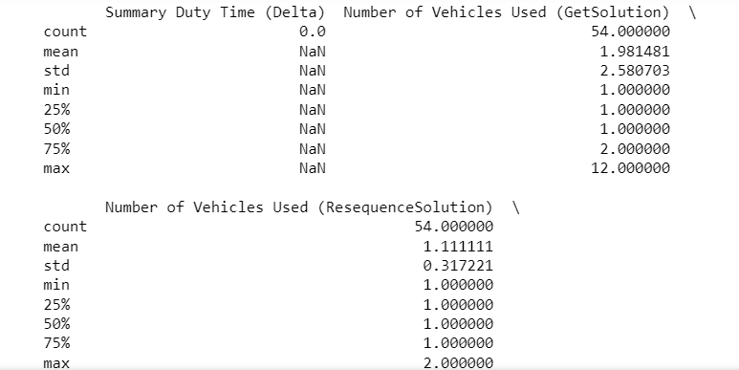

Figure 19: Statistical Summary

The number of vehicles used in the GetSolution varies from 1 to 12, with an average of about 2. The ResequenceSolution primarily uses 1 or 2 vehicles.

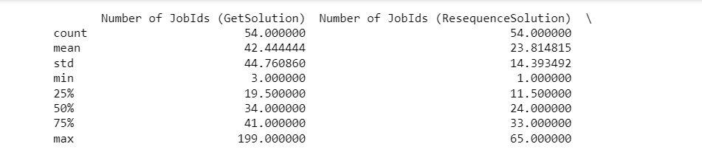

Figure 20: Statistical Summary

On average, there are about 42 jobs in the GetSolution and about 24 in the ResequenceSolution, indicating a reduction in jobs in the manually adjusted solutions.

From our initial data review, we've noticed a few key points. Planners often change routes, be it by rearranging job orders, adding new tasks, or removing some. This behavior fits with our goal of understanding why planners make these changes. We also saw a big difference in total distances between two sets of solutions. The 'ResequenceSolution' stands out with especially high values, suggesting there might be some issues or unusual data points that need a closer look. Additionally, some missing values in delta columns hint that we might not have all the information on how the original and adjusted plans compare.

### 5.10.2 Data Cleaning

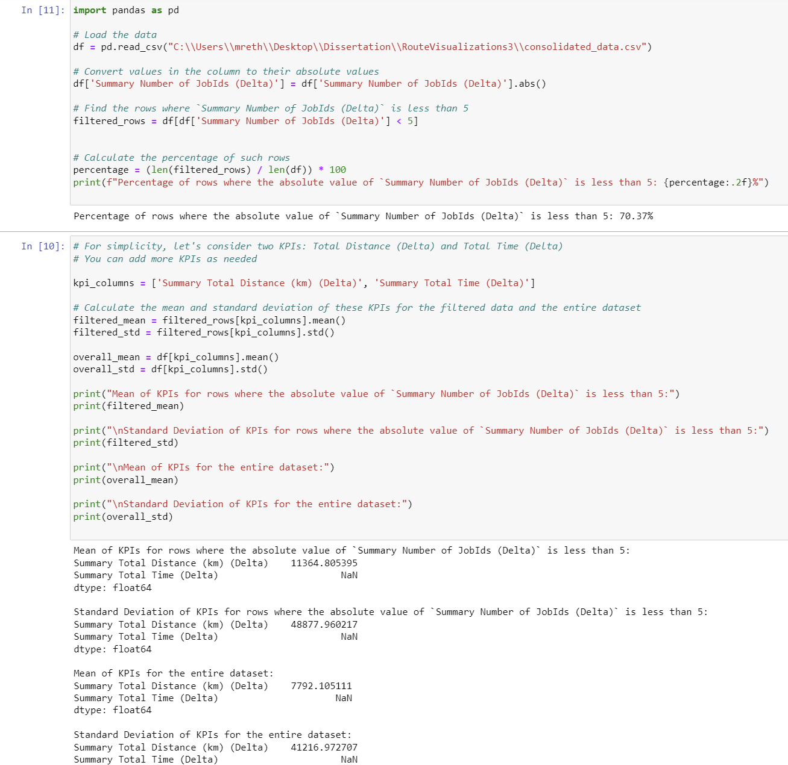

Figure 21: Data Cleaning

In our dataset, the **Summary Number of JobIds (Delta)** column shows the difference in job counts between our automated route solution and the one adjusted by planners. We noticed some routes had big differences, with the count being more than 5 jobs apart. This could mean that planners made major changes to some routes or removed many jobs for reasons we don't fully understand from the data alone.

To keep our analysis clear and focused, we decided to leave out these big differences. We're aiming to understand the typical, smaller adjustments planners make. By focusing on routes with smaller changes, we can better understand common planner preferences and how our automated solution might be improved. This way, we keep our study straightforward while still aiming for insightful results.

The data had further outliers which were found and cleaned using IQR Method, which detected 5 outliers.

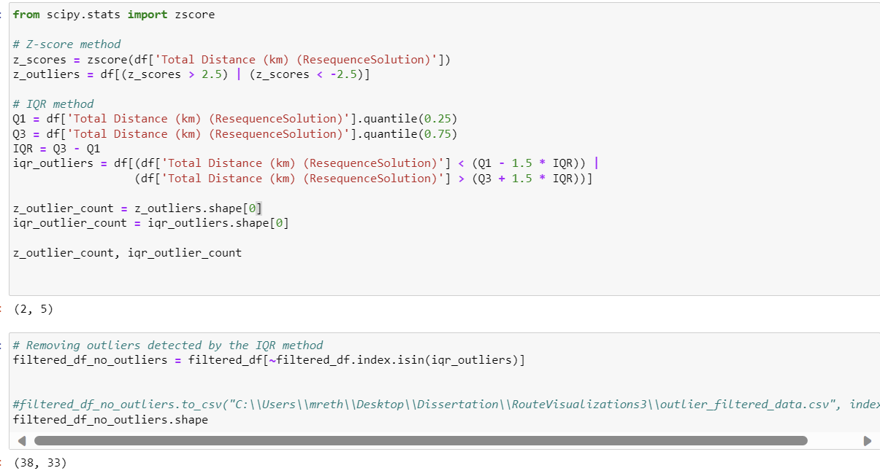

Figure 22: Outlier Detection Using IQR

### 5.10.3 Exploratory Data Analysis

In the exploratory data analysis (EDA), we focused on the column "Summary Total Distance (km) (Delta)" after data cleaning and generating a statistical summary. Here's a concise report of our findings:

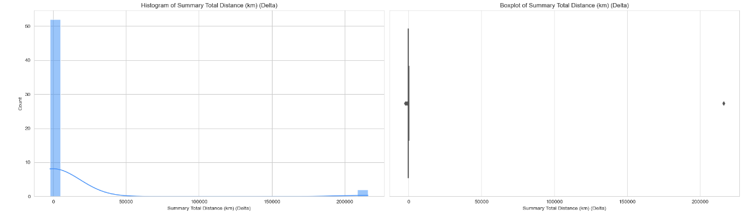

Figure 23: Histogram and Box Plot

**Histogram Analysis:**

* The distribution of "Summary Total Distance (km) (Delta)" is right-skewed, indicating that there are a few routes with significantly high differences in distance between the original and adjusted solutions.
* Most data points are concentrated on the left side of the distribution, suggesting that for most routes, the difference in distance is relatively small.

**Boxplot Analysis:**

* The boxplot confirms the presence of outliers on the higher end of the distribution, but these outliers were not removed during data preprocessing based on the IQR method.
* The interquartile range (IQR), representing the range between the 1st and 3rd quartiles, is relatively small, signifying that 50% of the data points fall within this narrow range.

### 5.10.4 Principal Component Analysis

In our exploratory data analysis (EDA) process, we have employed Principal Component Analysis (PCA) as a method for multivariate analysis. PCA is chosen to reduce the dimensionality of the data while preserving the maximum variance. This approach aids in gaining insights into the relationships between various features.

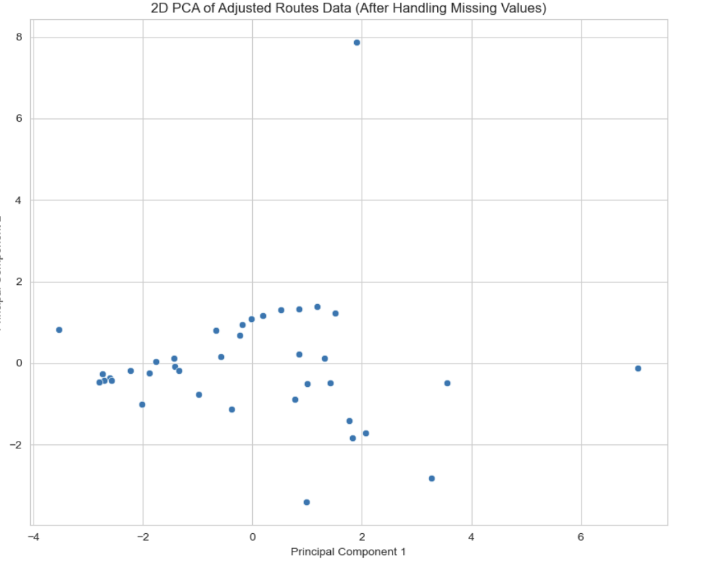

Figure 24: PCA plot

After performing PCA and reducing the data to just two dimensions, we can visualize the adjusted routes data in a scatter plot. This scatter plot offers a clear representation of how the data points are distributed across these two principal components.

The scatter plot reveals the presence of potential clusters or groupings of data points. These clusters may signify common characteristics or patterns within the manually adjusted routes.

### 5.10.5 K-Means Clustering

Following the insights gained from the PCA visualization, K-Means Clustering was employed to segment the data into distinct groups. K-Means is an iterative algorithm that partitions a dataset into k distinct, non-overlapping subsets (or clusters) based on their similarities. The objective is to minimize intra-cluster distances and maximize inter-cluster distances.

Steps Involved:

**Determination of Optimal Number of Clusters**:

The optimal number of clusters was determined using the Elbow Method. This method involves plotting the sum of squared distances for a range of cluster numbers, with the 'elbow' of the plot indicating the optimal number. It was found to be 3 in our case.

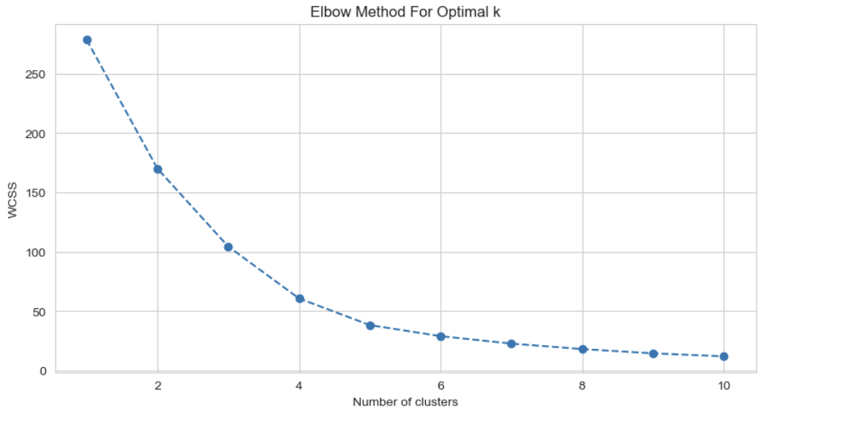

Figure 25: Elbow Method

**Clustering Execution**:

The data, already transformed by PCA, was further normalized to ensure uniform contribution of all features to the clustering process. The K-means algorithm was applied, segmenting the data into three distinct clusters based on their similarities in the PCA-transformed space.

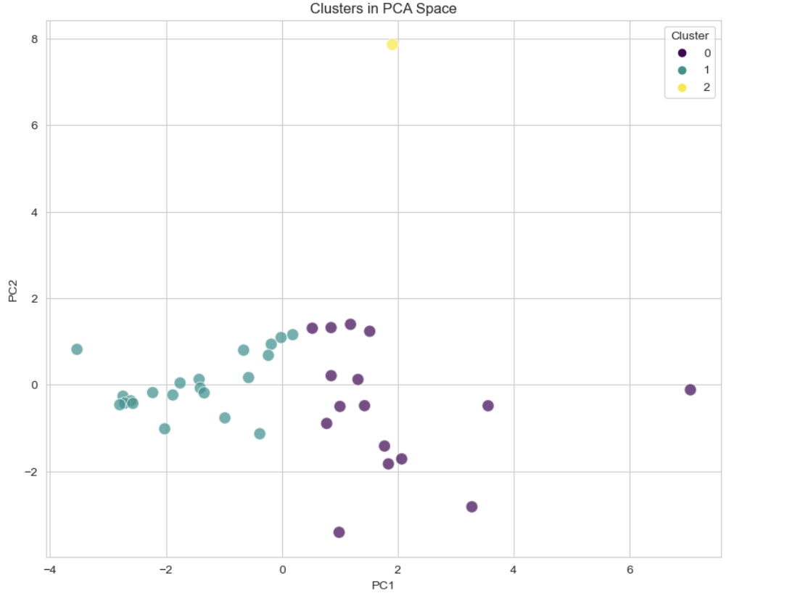

Figure 26: Cluster Analysis

**Mapping to Original Features**:

To understand the nature and characteristics of each cluster, they were mapped back to the original dataset. This step facilitated a more meaningful interpretation of each cluster based on real-world features and metrics.

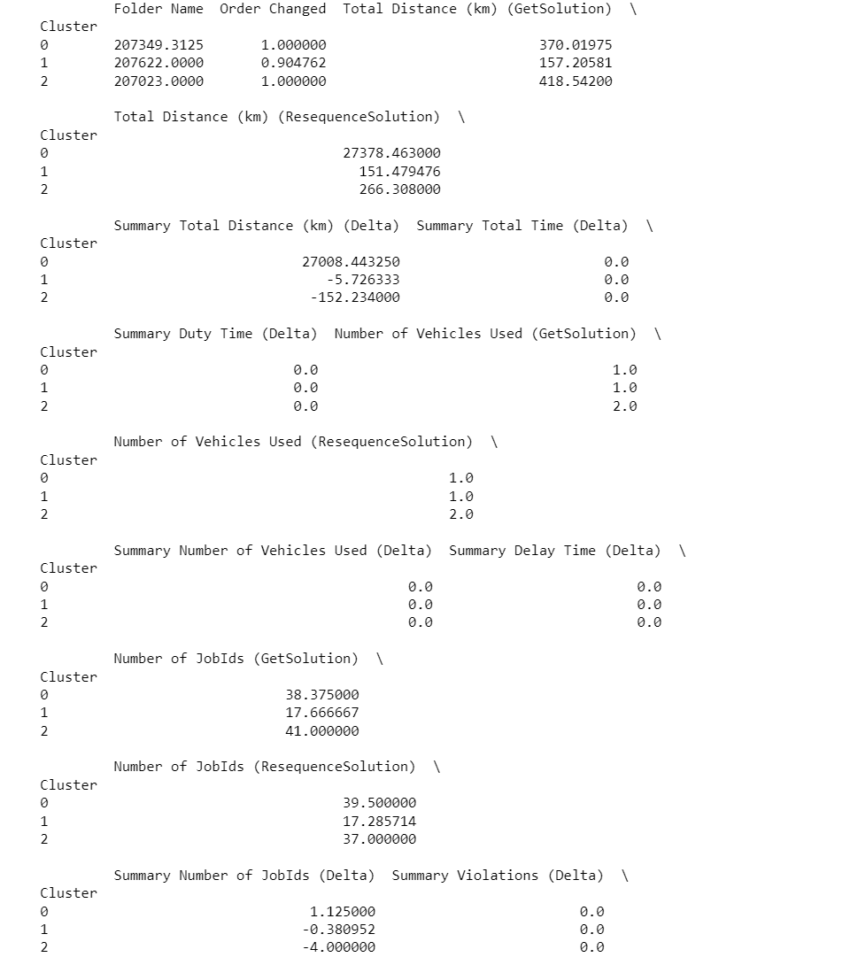

Figure 27: Cluster's Statistics

**Observations:**

**Cluster 0:**

* Original distance: ~370.02 km; Adjusted: ~27,378.46 km.
* Jobs: Original ~38.37; Adjusted ~39.5.
* Stops: Original ~17.56; Adjusted ~18.06.
* Represents routes with major increases in distance, likely due to specific constraints or objectives.

**Cluster 1:**

* Original distance: ~157.21 km; Adjusted: ~151.48 km.
* Jobs: Original ~17.67; Adjusted ~17.29.
* Stops: Original ~7.95; Adjusted ~7.86.
* Indicates routes with slight reductions post-adjustment.

**Cluster 2:**

* Original distance: ~418.54 km; Adjusted: ~266.31 km.
* Jobs: Original ~41; Adjusted ~37.
* Stops: Original 17; Adjusted 15.
* Features routes with notable reductions in distance and jobs post-adjustment**.**

Cluster 0 represents routes with significant increases in total distance after manual adjustments. This might indicate special cases where the planner had to make considerable changes to the route to meet certain constraints or objectives.

Cluster 1 represents routes with minor adjustments, both in terms of total distance and number of jobs/stops.

Cluster 2 represents routes with a reduction in total distance and number of jobs after manual adjustments.

### 5.10.6 Feature Importance Analysis

After clustering the data to identify distinct patterns in manual route adjustments, it's crucial to understand the significance of individual features in influencing these adjustments. The Feature Importance Analysis aims to identify and rank the features based on their contribution to the variance within the data, providing insights into which parameters are the most influential in manual route planning.

**Approach:**

1. **Data Preparation:** The dataset, already cleansed and filtered for outliers, is further split into features and target variable. The target variable in our context is the **Summary Total Distance (km) (Delta)**, which represents the manual adjustments in distance. The features encompass the rest of the metrics.
2. **Modelling using Random Forest:** The Random Forest algorithm, a popular ensemble learning method, is employed. Besides its capacity for accurate prediction, Random Forest provides a straightforward way to rank features based on their importance.
3. **Feature Ranking:** Upon training the Random Forest model on our dataset, we retrieve the feature importance scores. These scores are then sorted in descending order to rank the features.

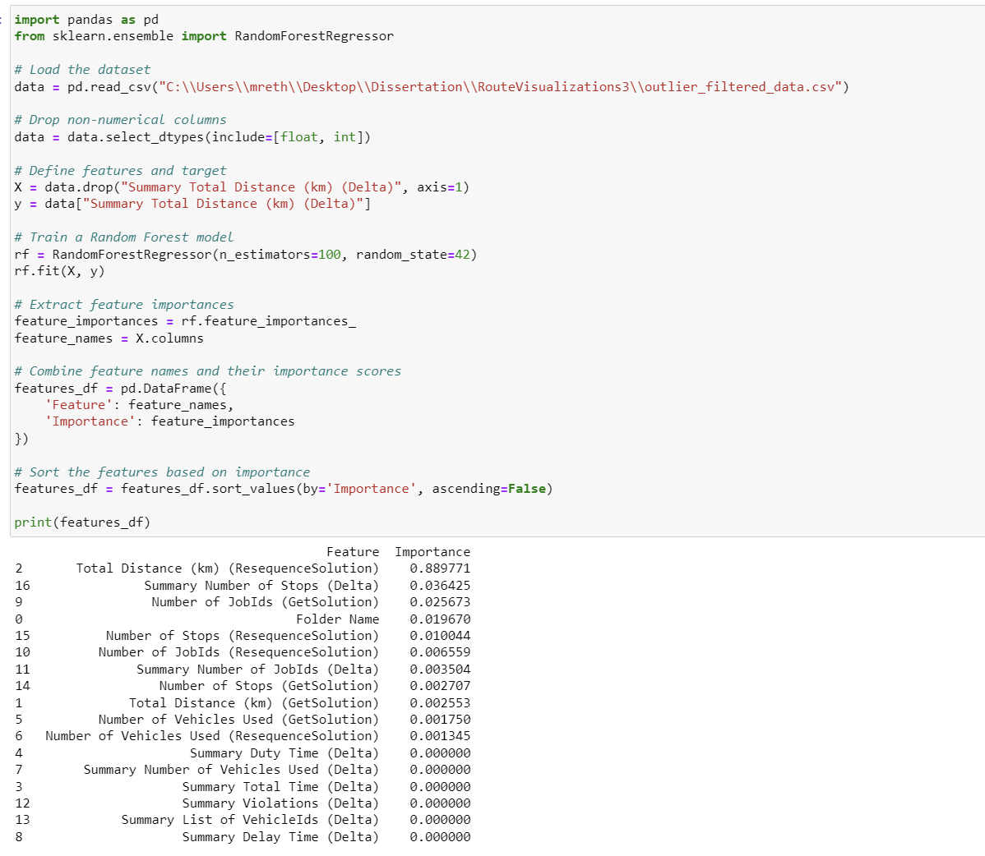

Figure 28: Feature Importance Analysis

**Observations from Feature Importance Analysis:**

* **Total Distance (km) (ResequenceSolution):** This feature emerges prominently, highlighting its importance in planners' decision-making. It suggests that the adjusted route's distance is a primary consideration during manual modifications.
* **Summary Number of Stops (Delta) & Number of JobIds (GetSolution):** Both these features play a significant role, emphasizing the weightage planners give to the number of stops and jobs while making adjustments.
* **Folder Name:** This feature's relevance hints that certain types of routes or categories might be more frequently adjusted by planners.

**Conclusions:**

From the analysis, it's evident which features or metrics are crucial for planners during their manual route adjustments:

1. **Distance as the Foremost Consideration:** The prominence of distance-related features in the importance ranking reinforces the idea that planners primarily aim to optimize route efficiency.
2. **Operational & Job-Related Adjustments:** The significance of metrics related to stops and job IDs underscores the operational aspects of manual adjustments. Planners seem to adjust routes based on operational needs, balancing workload, or specific job requirements.

### 5.10.7 Feature Importance Analysis Using Gradient Boosting Machines (XGBoost):

Using the XGBoost model, we derived the importance of features in our dataset:

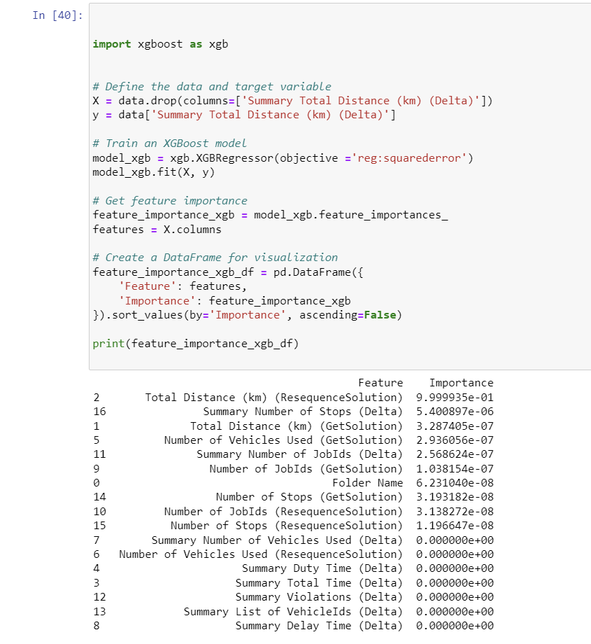

Figure 29: XGBoost

**Observations**:

1. **Total Distance (ResequenceSolution)**:
   * This feature greatly influences manual adjustments, with its importance score being nearly 100%. It highlights the emphasis planners put on the adjusted route's distance.
2. **Summary Number of Stops (Delta)**:
   * Though less influential than the total distance, this feature still impacts planner adjustments. It shows that changes in the number of stops between plans can affect decisions.
3. **Additional Features**:
   * Features such as Total Distance (GetSolution), Number of Vehicles Used (GetSolution), and Number of JobIds (GetSolution) play a role, but their influence is comparatively minor.

**Conclusions:**

* The XGBoost-based feature importance analysis further emphasizes the importance of the adjusted route's total distance in manual plan modifications. Planners prioritize this metric heavily when making adjustments.
* Other metrics, like the difference in the number of stops or the number of jobs in the original solution, also factor into the adjustments, but to a much lesser degree.
* The consistency in results from both the Random Forest and XGBoost models supports our findings.

From above observations, it's clear that the re-sequenced total distance is of paramount importance. This could imply that planners often adjust routes to optimize distance, possibly to save on fuel costs, reduce travel time, or meet other operational constraints.

### 5.10.8 Association Rule Mining

To further discover the hidden patterns and relationships within the dataset, especially the combinations of features that could frequently lead to certain manual adjustments, we employed Association Rule Mining. This technique is widely used to uncover relationships between seemingly unrelated data points in a dataset. In this project, we used the Apriori algorithm, a popular method in Association Rule Mining.

**Methodology:**

* **Feature Binarization**: To facilitate the application of the Apriori algorithm, we converted continuous variables into categorical ones. Features like 'Total Distance (both original and resequenced)' and 'Number of Jobs' were binarized based on quantiles. This transformed these features into interpretable categories such as 'Short Distance', 'Medium Distance', 'High Number of Jobs', etc.
* **Apriori Algorithm Application**: With the binarized dataset, the Apriori algorithm was applied to identify frequent item sets or combinations of features.

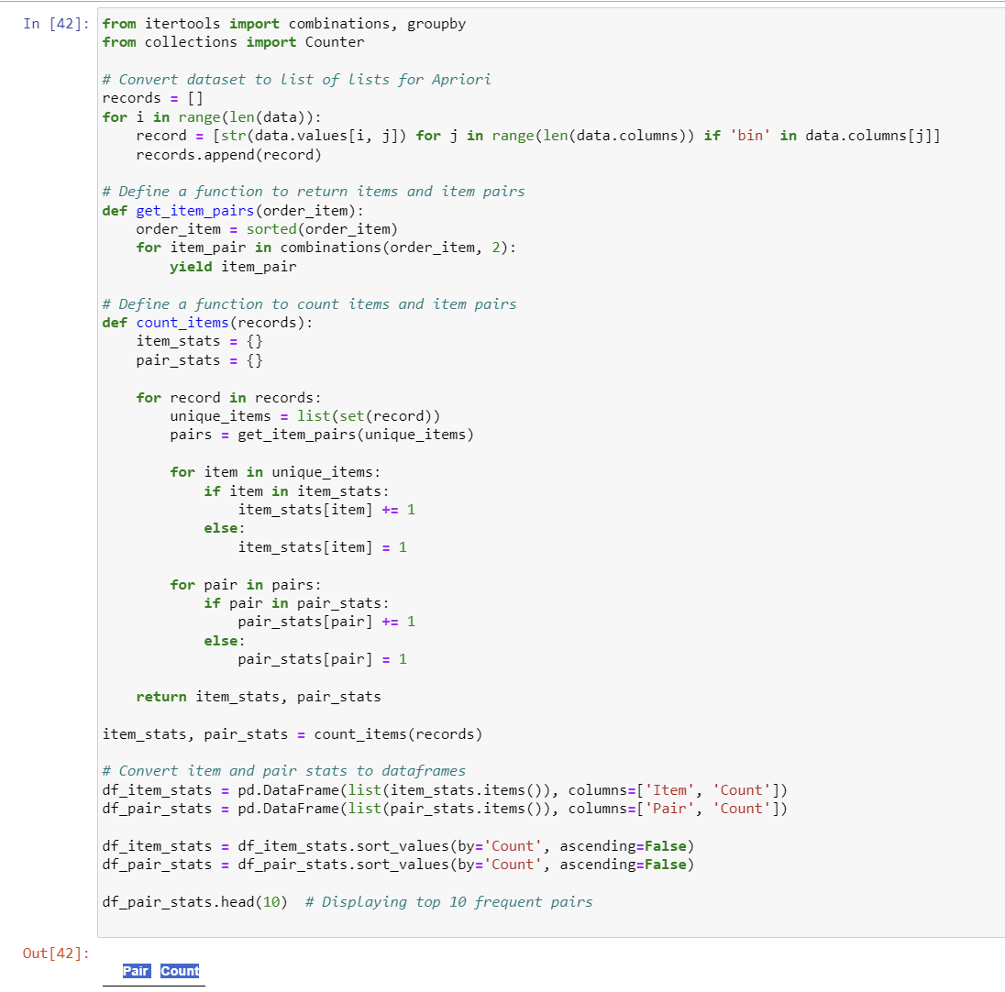

Figure 3: Apriori Algorithm

**Findings:**

No distinct frequent pairs of these binarized features were identified at the chosen support threshold. This suggests a lack of strong recurring patterns within the dataset for these attributes.

**Implications and Further Steps:**

The absence of prominent associations in our current analysis could indicate that the manual adjustments made by planners are influenced by a number of factors, some of which might not be quantitatively captured in the dataset.

# 

# Chapter 6: Conclusion and Limitations

## 6.1 Conclusion:

This research was initiated with the objective of uncovering the hidden preferences and decision-making processes of human planners when refining algorithmically suggested route plans. Through meticulous analysis and the use of diverse analytical techniques, we have examined the intricate patterns and underlying reasons that guide these manual adjustments.

The analysis revealed that while algorithmic solutions lay a foundational blueprint for route planning, they aren't the end-all. Human planners, with their hands-on experience and insights into real-world dynamics, are instrumental in tweaking these routes. The data's variability in job assignments, with some jobs omitted in the re-sequenced plans while others were added, showcases the fluidity inherent in manual route adjustments. Such modifications underscore the planners' adaptability to evolving operational demands, shifting customer needs, and unexpected logistical hurdles.

Another observation was the balance between efficiency and priorities. Though some re-sequenced routes became shorter, others did not - indicating efficiency competes with operational and customer needs.

Route sequence changes across plans hint at planners proactively adapting to dynamic factors like traffic and customer availability. Distance reductions without job relocation demonstrate optimizing paths while respecting spatial layouts. We also observed the operational challenges planners navigate, like introducing violations to meet immediate needs despite algorithm recommendations.

The exploratory data analysis (EDA) provided a clearer picture of the data's distribution. The right-skewed nature of the "Summary Total Distance (km) (Delta)" distribution suggests that significant differences in distances for certain routes exist, although most routes have relatively minor differences. The presence of outliers, as reflected in the boxplot, further validated our earlier assumptions.

The distinct clusters obtained through K-Means clustering indicated that planners did not take a one-size-fits-all approach but rather employed varied strategies depending on the route's specific context and constraints. For instance, the significant distance increases in some routes, as observed in Cluster 0, suggested that planners might have been dealing with particular operational limitations or objectives, leading them to opt for longer routes. The existence of Cluster 1, comprising routes with only minor tweaks, showed that in many cases, the algorithmically generated routes closely aligned with the planners’ expectations, requiring just slight refinements. Meanwhile, the notable reductions in distance and jobs for certain routes in Cluster 2 hinted at planners continuously seeking optimization opportunities - perhaps to save on costs, reduce travel times, or address pressing logistical needs It highlighted the adaptive interplay between algorithmic and human judgments, showcasing the planners’ versatility, strategic thinking, and the multitude of factors weighed when adjusting routes.

Utilizing the Random Forest and XGBoost models, we analysed the relative importance of different features, providing insights into the core factors shaping planner decisions. The pronounced importance of 'Total Distance (km) (ResequenceSolution)' underscores its central role in manual adjustments, highlighting the emphasis on optimizing route lengths. Furthermore, metrics such as the number of stops and job IDs substantiates the notion that planners strike a balance between route efficiency and meeting operational requirements.

Our exploration with Association Rule Mining aimed to discover underlying patterns that might guide manual route adjustments The lack of clear patterns suggests that the manual adjustments by planners are driven by diverse considerations. This complexity indicates that beyond the data we analysed, there could be numerous external factors influencing these adjustments.

## 6.2 Limitations:

1. **Data Constraints**: While the report offers an in-depth exploration of the dataset in hand, the conclusions and findings are inherently bound by the quality, comprehensiveness, and representativeness of this data. There may be external factors and variables not captured in the dataset that could influence manual route adjustments.
2. **Algorithmic Limitations**: The research employed specific analytical methods like Random Forest, XGBoost, and Association Rule Mining. The results and inferences are thus tied to the strengths and limitations of these techniques. Different algorithms or methods might yield varying insights.
3. **Subjectivity in Human Decision-making**: While the report delves deep into the quantifiable aspects of planner decision-making, the inherent subjectivity in human decisions means that not all planners' preferences can be completely rationalized or understood purely through data.
4. **Outlier Influence**: The report acknowledges the presence of outliers in the data. Even though these were accounted for, outliers can sometimes have a disproportionate impact on certain analyses, potentially skewing results or insights.
5. **External Factors**: The report hints at numerous external factors influencing route adjustments. However, without explicit data on these factors (like real-time traffic conditions, vehicle breakdowns, or sudden changes in customer preferences), the research can only speculate on their impact.
6. **Temporal Dynamics**: The research offers insights into route sequence changes, suggesting planners adapt to factors like traffic and customer availability. However, without continuous and dynamic data reflecting these real-time changes, the depth of this adaptability remains partially explored.

## 6.3 Recommendations for Future Actions:

1. **Comprehensive Data Collection**: Given the constraints noted in the data, it is recommended that future studies integrate a more comprehensive dataset. Incorporating real-time data, including traffic conditions, vehicle health metrics, and dynamic customer preferences, can offer richer insights into the planners' decision-making processes.
2. **Experiment with Diverse Analytical Techniques**: While the present study employed techniques like Random Forest and XGBoost, exploring other advanced machine learning or data mining methods could unveil deeper insights or validate the findings of this research.
3. **Human-Centric Studies**: A qualitative approach, involving interviews or surveys with planners, could provide a more nuanced understanding of the subjectivity inherent in human decision-making. This would complement the quantitative findings and provide a holistic view.
4. **Temporal Studies**: Given the dynamic nature of route planning, it would be worthwhile to conduct temporal analyses, observing how route adjustments change over different times of the day, week, or even seasonally.
5. **Feedback Mechanisms**: Implementing a feedback mechanism within the P&O product could allow planners to provide reasons for their manual adjustments. This would offer direct insights into their thought processes and the challenges they face.

# 7.0 References

Agatz, N. A. H., Erera, A. L., Savelsbergh, M. W. P., & Wang, X. (2011). Dynamic ride-sharing: A simulation study in metro Atlanta. *Transportation Research Part B: Methodological*, *45*(9), 1450–1464. https://doi.org/10.1016/j.trb.2011.05.017

Ageron, B., Gunasekaran, A., & Spalanzani, A. (2012). Sustainable supply management: An empirical study. *International Journal of Production Economics*, *140*(1), 168–182. https://doi.org/10.1016/j.ijpe.2011.04.007

Alotaibi, I., Abido, M. A., Khalid, M., & Savkin, A. V. (2020). A Comprehensive Review of Recent Advances in Smart Grids: A Sustainable Future with Renewable Energy Resources. *Energies*, *13*(23), 6269. https://doi.org/10.3390/en13236269

Ambrosini, V., & Bowman, C. (2001). Tacit Knowledge: Some Suggestions for Operationalization. *Journal of Management Studies*, *38*(6), 811–829. https://doi.org/10.1111/1467-6486.00260

Barth, M., & Boriboonsomsin, K. (2008). Real-World Carbon Dioxide Impacts of Traffic Congestion. *Transportation Research Record: Journal of the Transportation Research Board*, *2058*(1), 163–171. https://doi.org/10.3141/2058-20

Berbeglia, G., Cordeau, J.-F., & Laporte, G. (2010). Dynamic pickup and delivery problems. *European Journal of Operational Research*, *202*(1), 8–15. https://doi.org/10.1016/j.ejor.2009.04.024

Bertsimas, D. J., & van Ryzin, G. (1991). A Stochastic and Dynamic Vehicle Routing Problem in the Euclidean Plane. *Operations Research*, *39*(4), 601–615. https://doi.org/10.1287/opre.39.4.601

Boyer, K. K., Prud’homme, A. M., & Chung, W. (2009). THE LAST MILE CHALLENGE: EVALUATING THE EFFECTS OF CUSTOMER DENSITY AND DELIVERY WINDOW PATTERNS. *Journal of Business Logistics*, *30*(1), 185–201. https://doi.org/10.1002/j.2158-1592.2009.tb00104.x

Braekers, K., Ramaekers, K., & Van Nieuwenhuyse, I. (2016). The vehicle routing problem: State of the art classification and review. *Computers & Industrial Engineering*, *99*, 300–313. https://doi.org/10.1016/j.cie.2015.12.007

Bräysy, O., & Gendreau, M. (2005). Vehicle Routing Problem with Time Windows, Part I: Route Construction and Local Search Algorithms. *Transportation Science*, *39*(1), 104–118. https://doi.org/10.1287/trsc.1030.0056

Church, A., Frost, M., & Sullivan, K. (2000). Transport and social exclusion in London. *Transport Policy*, *7*(3), 195–205. https://doi.org/10.1016/S0967-070X(00)00024-X

Clarke, G., & Wright, J. W. (1964). Scheduling of Vehicles from a Central Depot to a Number of Delivery Points. *Operations Research*, *12*(4), 568–581. https://doi.org/10.1287/opre.12.4.568

Cook, W. J., Applegate, D. L., Bixby, R. E., & Chvátal, V. (2011). *The Traveling Salesman Problem*. Princeton University Press. https://doi.org/10.1515/9781400841103

Cordeau, J.-F., Laporte, G., Savelsbergh, M., & Vigo, D. (2007). Vehicle Routing. In *Transportation, handbooks in operations research and management science* (Vol. 14, pp. 195–224).

Crainic, T. G., & Kim, K. H. (2006). Intermodal Transportation. *Transportation*, *14*, 467–537.

Crainic, T. G., & Laporte, G. (1997). Planning models for freight transportation. *European Journal of Operational Research*, *97*(3), 409–438. https://EconPapers.repec.org/RePEc:eee:ejores:v:97:y:1997:i:3:p:409-438

Crainic, T. G., Ricciardi, N., & Storchi, G. (2004). Advanced freight transportation systems for congested urban areas. *Transportation Research Part C: Emerging Technologies*, *12*(2), 119–137. https://doi.org/10.1016/j.trc.2004.07.002

Cui, Q., & Lei, Y. (2023). Pathways analysis to reducing aircraft emissions for China-Foreign routes. *Npj Climate Action*, *2*(1), 15. https://doi.org/10.1038/s44168-023-00047-4

Dablanc, L. (2007). Goods transport in large European cities: Difficult to organize, difficult to modernize. *Transportation Research Part A: Policy and Practice*, *41*(3), 280–285. https://doi.org/10.1016/j.tra.2006.05.005

de Koster, R., Le-Duc, T., & Roodbergen, K. J. (2007). Design and control of warehouse order picking: A literature review. *European Journal of Operational Research*, *182*(2), 481–501. https://doi.org/10.1016/j.ejor.2006.07.009

Delling, D., Sanders, P., Schultes, D., & Wagner, D. (2009). *Engineering Route Planning Algorithms* (pp. 117–139). https://doi.org/10.1007/978-3-642-02094-0_7

Demir, E., Bektaş, T., & Laporte, G. (2011). A comparative analysis of several vehicle emission models for road freight transportation. *Transportation Research Part D: Transport and Environment*, *16*(5), 347–357. https://doi.org/10.1016/j.trd.2011.01.011

Dijkstra, E. W. (1959). A note on two problems in connexion with graphs. *Numerische Mathematik*, *1*(1), 269–271. https://doi.org/10.1007/BF01386390

Dorigo, M., & Stützle, T. (2010). *Ant Colony Optimization: Overview and Recent Advances* (pp. 227–263). https://doi.org/10.1007/978-1-4419-1665-5_8

Durach, C. F., Kurpjuweit, S., & Wagner, S. M. (2017). The impact of additive manufacturing on supply chains. *International Journal of Physical Distribution & Logistics Management*, *47*(10), 954–971. https://doi.org/10.1108/IJPDLM-11-2016-0332

Ehmke, J. F., & Campbell, A. M. (2014). Customer acceptance mechanisms for home deliveries in metropolitan areas. *European Journal of Operational Research*, *233*(1), 193–207. https://doi.org/10.1016/j.ejor.2013.08.028

Ericsson, E., Larsson, H., & Brundell-Freij, K. (2006). Optimizing route choice for lowest fuel consumption – Potential effects of a new driver support tool. *Transportation Research Part C: Emerging Technologies*, *14*(6), 369–383. https://doi.org/10.1016/j.trc.2006.10.001

Gevaers, R., Van de Voorde, E., & Vanelslander, T. (2014). Cost Modelling and Simulation of Last-mile Characteristics in an Innovative B2C Supply Chain Environment with Implications on Urban Areas and Cities. *Procedia - Social and Behavioral Sciences*, *125*, 398–411. https://doi.org/10.1016/j.sbspro.2014.01.1483

Goodfellow, Ian and Bengio, Yoshua and Courville, & Aaron. (2016). *Deep learning*. MIT Press.

Gupta, A., & Saini, S. (2017). An Enhanced Ant Colony Optimization Algorithm for Vehicle Routing Problem with Time Windows. *2017 Ninth International Conference on Advanced Computing (ICoAC)*, 267–274. https://doi.org/10.1109/ICoAC.2017.8441175

He, A., Kyung Kyoon Bae, Newman, T. R., Gaeddert, J., Kyouwoong Kim, Menon, R., Morales-Tirado, L., Neel, J. J., Youping Zhao, Reed, J. H., & Tranter, W. H. (2010). A Survey of Artificial Intelligence for Cognitive Radios. *IEEE Transactions on Vehicular Technology*, *59*(4), 1578–1592. https://doi.org/10.1109/TVT.2010.2043968

He, F., Yin, Y., & Zhou, J. (2013). Integrated pricing of roads and electricity enabled by wireless power transfer. *Transportation Research Part C: Emerging Technologies*, *34*, 1–15. https://doi.org/10.1016/j.trc.2013.05.005

Hsiao, K.-L., & Chen, C.-C. (2016). What drives in-app purchase intention for mobile games? An examination of perceived values and loyalty. *Electronic Commerce Research and Applications*, *16*, 18–29. https://doi.org/10.1016/j.elerap.2016.01.001

Jan K. Lenstra, & H. G. Rinnooy Kan. (2006). Complexity of vehicle routing and scheduling problems. *Networks*, *11*. @article{Lenstra1981ComplexityOV,  title={Complexity of vehicle routing and scheduling problems},  author={Jan Karel Lenstra and Alexander H. G. Rinnooy Kan},  journal={Networks},  year={1981},  volume={11},  pages={221-227},  url={https://api.semanticscholar.org/CorpusID:206312678} }

Jun, J., Guensler, R., & Ogle, J. (2011). Differences in observed speed patterns between crash-involved and crash-not-involved drivers: Application of in-vehicle monitoring technology. *Transportation Research Part C: Emerging Technologies*, *19*(4), 569–578. https://doi.org/10.1016/j.trc.2010.09.005

Laporte, G. (1992). The vehicle routing problem: An overview of exact and approximate algorithms. *European Journal of Operational Research*, *59*(3), 345–358. https://doi.org/10.1016/0377-2217(92)90192-C

Liimatainen, H., Stenholm, P., Tapio, P., & McKinnon, A. (2012). Energy efficiency practices among road freight hauliers. *Energy Policy*, *50*, 833–842. https://doi.org/10.1016/j.enpol.2012.08.049

Lo, S.-C., & Chuang, Y.-L. (2023). Vehicle Routing Optimization with Cross-Docking Based on an Artificial Immune System in Logistics Management. *Mathematics*, *11*(4), 811. https://doi.org/10.3390/math11040811

Makridakis, S., Spiliotis, E., & Assimakopoulos, V. (2018). Statistical and Machine Learning forecasting methods: Concerns and ways forward. *PLOS ONE*, *13*(3), e0194889. https://doi.org/10.1371/journal.pone.0194889

Marchet, G., Melacini, M., & Perotti, S. (2014). Environmental sustainability in logistics and freight transportation. *Journal of Manufacturing Technology Management*, *25*(6), 775–811. https://doi.org/10.1108/JMTM-06-2012-0065

Martin Christopher. (2023). *Logistics and Supply Chain Management* (6th ed.). FT Publishing International. https://www.pearson.com/en-gb/subject-catalog/p/logistics-and-supply-chain-management/P200000007134/9781292416205

Mckinnon, A. (2007). *CO 2 Emissions from Freight Transport in the UK: Report prepared for the Climate Change Working Group of the Commission for Integrated Transport 2007*. https://doi.org/10.13140/RG.2.2.10866.81600

McKinnon, A. C. (2007). Decoupling of Road Freight Transport and Economic Growth Trends in the UK: An Exploratory Analysis. *Transport Reviews*, *27*(1), 37–64. https://doi.org/10.1080/01441640600825952

Miller, Harvey J and Shaw, & Shih-Lung. (2001). *Geographic information systems for transportation: principles and applications*. Spatial Information Systems. https://books.google.co.uk/books?hl=en&lr=&id=2XjtJIUG-gMC&oi=fnd&pg=PA3&dq=Miller,+H.+J.,+%26+Shaw,+S.+L.+(2001).+Geographic+Information+Systems+for+Transportation:+Principles+and+Applications.+Oxford+University+Press&ots=JIDmOtE1Yt&sig=JF38hSfoDdCS4PotyICcnfMS7YA#v=onepage&q&f=false

Morganti, E., Seidel, S., Blanquart, C., Dablanc, L., & Lenz, B. (2014). The Impact of E-commerce on Final Deliveries: Alternative Parcel Delivery Services in France and Germany. *Transportation Research Procedia*, *4*, 178–190. https://doi.org/10.1016/j.trpro.2014.11.014

Paolo Toth, & Daniele Vigo. (2014). *Vehicle RoutingProblems, Methods,  and Applications* (2nd ed.). Society for Industrial and Applied Mathematics. https://doi.org/10.1137/1.9781611973594.fm

Parasuraman, Raja and Rizzo, & Matthew. (2006). *Neuroergonomics: The brain at work* (Vol. 3). Oxford University Press.

Parsa, P., Shbool, M., Rossetti, M., Zhang, S., & Pohl, E. (2016, September). *A Multi-Objective Decision Model for Supply Chain Collaboration Programs*.

Pérez Rivera, A. E., & Mes, M. R. K. (2019). Integrated scheduling of drayage and long-haul operations in synchromodal transport. *Flexible Services and Manufacturing Journal*, *31*(3), 763–806. https://doi.org/10.1007/s10696-019-09336-9

Pfoser, S., Treiblmaier, H., & Schauer, O. (2016). Critical Success Factors of Synchromodality: Results from a Case Study and Literature Review. *Transportation Research Procedia*, *14*, 1463–1471. https://doi.org/10.1016/j.trpro.2016.05.220

Psaraftis, H. N., Wen, M., & Kontovas, C. A. (2016). Dynamic vehicle routing problems: Three decades and counting. *Networks*, *67*(1), 3–31. https://doi.org/10.1002/net.21628

Rand, G. K. (1988). Vehicle Routing: Methods and Studies (Studies in Management Science and Systems, Volume 16). *Journal of the Operational Research Society*, *39*(10), 979–980. https://doi.org/10.1057/jors.1988.167

Rodrigue, Jean-Paul and Slack, Brian and Comtois, & Claude. (2001). *Green Logistics. In: Handbook of Logistics And Supply-Chain Management*. https://trid.trb.org/view/696227

Rodrigue, J.-P. (2020). *The Geography of Transport Systems*. Routledge. https://doi.org/10.4324/9780429346323

Savelsbergh, M., & Van Woensel, T. (2016). 50th Anniversary Invited Article—City Logistics: Challenges and Opportunities. *Transportation Science*, *50*(2), 579–590. https://doi.org/10.1287/trsc.2016.0675

Savelsbergh, M. W. P. (1992). The Vehicle Routing Problem with Time Windows: Minimizing Route Duration. *ORSA Journal on Computing*, *4*(2), 146–154. https://doi.org/10.1287/ijoc.4.2.146

Searcy, C., & Buslovich, R. (2014). Corporate Perspectives on the Development and Use of Sustainability Reports. *Journal of Business Ethics*, *121*(2), 149–169. https://doi.org/10.1007/s10551-013-1701-7

Seuring, S., & Müller, M. (2008). From a literature review to a conceptual framework for sustainable supply chain management. *Journal of Cleaner Production*, *16*(15), 1699–1710. https://doi.org/10.1016/j.jclepro.2008.04.020

Sharp, H., Rogers, Y., & Preece, J. (2007). *Interaction Design: Beyond Human Computer Interaction*. John Wiley & Sons, Inc.

Thomas H. Davenport, & Julia Kirby. (2016). *Only Humans Need Apply: Winners and Losers in the Age of Smart Machines*. HarperCollins. https://books.google.co.uk/books/about/Only_Humans_Need_Apply.html?id=ZRp2CgAAQBAJ&redir_esc=y

Tian, F. (2016). An agri-food supply chain traceability system for China based on RFID & blockchain technology. *2016 13th International Conference on Service Systems and Service Management (ICSSSM)*, 1–6. https://doi.org/10.1109/ICSSSM.2016.7538424

Toth, P., & Vigo, D. (Eds.). (2002). *The Vehicle Routing Problem*. Society for Industrial and Applied Mathematics. https://doi.org/10.1137/1.9780898718515

Van Duin, J. h. r. (Ron), Tavasszy, L. A., & Quak, H. (2013). Towards E(lectric)-urban freight: First promising steps in the electric vehicle revolution. *European Transport Europei*, *2013*.

van Lint, J. W. C., van Zuylen, H. J., & Tu, H. (2008). Travel time unreliability on freeways: Why measures based on variance tell only half the story. *Transportation Research Part A: Policy and Practice*, *42*(1), 258–277. https://doi.org/10.1016/j.tra.2007.08.008

Venkatesh, Morris, Davis, & Davis. (2003). User Acceptance of Information Technology: Toward a Unified View. *MIS Quarterly*, *27*(3), 425. https://doi.org/10.2307/30036540

Verdonck, L., Beullens, P., Caris, A., Ramaekers, K., & Janssens, G. K. (2016). Analysis of collaborative savings and cost allocation techniques for the cooperative carrier facility location problem. *Journal of the Operational Research Society*, *67*(6), 853–871. https://doi.org/10.1057/jors.2015.106

Visser, J., Nemoto, T., & Browne, M. (2014). Home Delivery and the Impacts on Urban Freight Transport: A Review. *Procedia - Social and Behavioral Sciences*, *125*, 15–27. https://doi.org/10.1016/j.sbspro.2014.01.1452

Viu-Roig, M., & Alvarez-Palau, E. J. (2020). The Impact of E-Commerce-Related Last-Mile Logistics on Cities: A Systematic Literature Review. *Sustainability*, *12*(16), 6492. https://doi.org/10.3390/su12166492

Wang, G., Gunasekaran, A., Ngai, E. W. T., & Papadopoulos, T. (2016). Big data analytics in logistics and supply chain management: Certain investigations for research and applications. *International Journal of Production Economics*, *176*, 98–110. https://doi.org/10.1016/j.ijpe.2016.03.014

Woodburn, A.G., B., & Allen, J. (2005). Urban freight consolidation centres. *Logistics Research Network Annual Conference*. https://ukerc.rl.ac.uk/pdf/RR3_Urban_Freight_Consolidation_Centre_Report.pdf

Zhang, X., Li, R. Y. M., Sun, Z., Li, X., Samad, S., Comite, U., & Matac, L. M. (2022). Supply Chain Integration and Its Impact on Operating Performance: Evidence from Chinese Online Companies. *Sustainability*, *14*(21), 14330. https://doi.org/10.3390/su142114330

# 8.0 Appendix A- codes

The complete Jupyter notebook with all analyses can be found at [[this link]](https://github.com/akash0804/Dissertation_Project_VRP.git).

import pandas as pd

# Load the data

data_path = r"C:\Users\mreth\Desktop\Dissertation\RouteVisualizations3\consolidated_data.csv"

df = pd.read_csv(data_path)

print(df.head())

# Overview of the data

print(df.info())

# Descriptive statistics

print(df.describe())

# Load the data

df = pd.read_csv("C:\\Users\\mreth\\Desktop\\Dissertation\\RouteVisualizations3\\consolidated_data.csv")

# Convert values in the column to their absolute values

df['Summary Number of JobIds (Delta)'] = df['Summary Number of JobIds (Delta)'].abs()

# Find the rows where `Summary Number of JobIds (Delta)` is less than 5

filtered_rows = df[df['Summary Number of JobIds (Delta)'] < 5]

# Calculate the percentage of such rows

percentage = (len(filtered_rows) / len(df)) * 100

print(f"Percentage of rows where the absolute value of `Summary Number of JobIds (Delta)` is less than 5: {percentage:.2f}%")

kpi_columns = ['Summary Total Distance (km) (Delta)', 'Summary Total Time (Delta)']

# Calculate the mean and standard deviation of these KPIs for the filtered data and the entire dataset

filtered_mean = filtered_rows[kpi_columns].mean()

filtered_std = filtered_rows[kpi_columns].std()

overall_mean = df[kpi_columns].mean()

overall_std = df[kpi_columns].std()

print("Mean of KPIs for rows where the absolute value of `Summary Number of JobIds (Delta)` is less than 5:")

print(filtered_mean)

print("\nStandard Deviation of KPIs for rows where the absolute value of `Summary Number of JobIds (Delta)` is less than 5:")

print(filtered_std)

print("\nMean of KPIs for the entire dataset:")

print(overall_mean)

print("\nStandard Deviation of KPIs for the entire dataset:")

print(overall_std)

# Load your data

df = pd.read_csv("C:\\Users\\mreth\\Desktop\\Dissertation\\RouteVisualizations3\\consolidated_data.csv")

# Filter rows where the absolute value of 'Summary Number of JobIds (Delta)' is less than or equal to 5

filtered_df = df[abs(df['Summary Number of JobIds (Delta)']) <= 5]

# If you want to save the filtered data to a new CSV

filtered_df.to_csv("C:\\Users\\mreth\\Desktop\\Dissertation\\RouteVisualizations3\\filtered_data.csv", index=False)

missing_data = filtered_df.isnull().sum()

print(missing_data)

filtered_df = filtered_df.fillna(0)

missing_data = filtered_df.isnull().sum()

print(missing_data)

summary_stats = filtered_df.describe()

print(summary_stats)

import matplotlib.pyplot as plt

filtered_df['Total Distance (km) (GetSolution)'].hist()

plt.xlabel('Total Distance (km) (GetSolution)')

plt.ylabel('Frequency')

plt.title('Distribution of Total Distance (km) (GetSolution)')

plt.show()

from scipy.stats import zscore

# Z-score method

z_scores = zscore(df['Total Distance (km) (ResequenceSolution)'])

z_outliers = df[(z_scores > 2.5) | (z_scores < -2.5)]

# IQR method

Q1 = df['Total Distance (km) (ResequenceSolution)'].quantile(0.25)

Q3 = df['Total Distance (km) (ResequenceSolution)'].quantile(0.75)

IQR = Q3 - Q1

iqr_outliers = df[(df['Total Distance (km) (ResequenceSolution)'] < (Q1 - 1.5 * IQR)) |

                  (df['Total Distance (km) (ResequenceSolution)'] > (Q3 + 1.5 * IQR))]

z_outlier_count = z_outliers.shape[0]

iqr_outlier_count = iqr_outliers.shape[0]

z_outlier_count, iqr_outlier_count

# Removing outliers detected by the IQR method

filtered_df_no_outliers = filtered_df[~filtered_df.index.isin(iqr_outliers)]

#filtered_df_no_outliers.to_csv("C:\\Users\\mreth\\Desktop\\Dissertation\\RouteVisualizations3\\outlier_filtered_data.csv", index=False)

filtered_df_no_outliers.shape

import matplotlib.pyplot as plt

import seaborn as sns

# Setting up the style

sns.set_style("whitegrid")

# Initialize the figure

plt.figure(figsize=(20, 6))

# Create subplots: Histogram and Boxplot

plt.subplot(1, 2, 1)

sns.histplot(df['Summary Total Distance (km) (Delta)'], bins=30, kde=True, color="dodgerblue")

plt.title('Histogram of Summary Total Distance (km) (Delta)')

plt.subplot(1, 2, 2)

sns.boxplot(x=df['Summary Total Distance (km) (Delta)'], color="dodgerblue")

plt.title('Boxplot of Summary Total Distance (km) (Delta)')

plt.tight_layout()

plt.show()

# Scatter plot to visualize the relationship between

# Summary Total Distance (km) (Delta) and Number of Stops (ResequenceSolution)

plt.figure(figsize=(12, 6))

sns.scatterplot(x=df['Number of Stops (ResequenceSolution)'], y=df['Summary Total Distance (km) (Delta)'], color="dodgerblue", alpha=0.6)

plt.title('Scatter plot of Summary Total Distance (km) (Delta) vs. Number of Stops (ResequenceSolution)')

plt.xlabel('Number of Stops (ResequenceSolution)')

plt.ylabel('Summary Total Distance (km) (Delta)')

plt.show()

from sklearn.decomposition import PCA

import numpy as np

numeric_df = filtered_df.select_dtypes(include=['float64', 'int64'])

# Standardizing the data

standardized_df = (numeric_df - numeric_df.mean()) / numeric_df.std()

nan_values = standardized_df.isnull().sum()

infinite_values = (np.isinf(standardized_df)).sum()

nan_values, infinite_values

# Filling NaN values with 0 for standardized dataset

standardized_df_filled = standardized_df.fillna(0)

# Applying PCA on the filled dataset

pca_filled = PCA(n_components=2)

principal_components_filled = pca_filled.fit_transform(standardized_df_filled)

principal_df_filled = pd.DataFrame(data=principal_components_filled, columns=['PC1', 'PC2'])

# Plotting the 2D projection

plt.figure(figsize=(10, 8))

sns.scatterplot(x=principal_df_filled["PC1"], y=principal_df_filled["PC2"])

plt.title('2D PCA of Adjusted Routes Data (After Handling Missing Values)')

plt.xlabel('Principal Component 1')

plt.ylabel('Principal Component 2')

plt.grid(True)

plt.show()

from sklearn.cluster import KMeans

wcss = []

for i in range(1, 11):

    kmeans = KMeans(n_clusters=i, init='k-means++', max_iter=300, n_init=10, random_state=0)

    kmeans.fit(principal_df_filled)

    wcss.append(kmeans.inertia_)

# Plot the Elbow method

plt.figure(figsize=(10,5))

plt.plot(range(1, 11), wcss, marker='o', linestyle='--')

plt.title('Elbow Method For Optimal k')

plt.xlabel('Number of clusters')

plt.ylabel('WCSS')

plt.show()

# Apply KMeans clustering with the optimal number of clusters (based on elbow method result; k=3)

optimal_clusters = 3

kmeans = KMeans(n_clusters=optimal_clusters, init='k-means++', max_iter=300, n_init=10, random_state=0)

clustered_data = kmeans.fit_predict(principal_df_filled)

# Adding cluster information to the principal_df_filled

principal_df_filled['Cluster'] = clustered_data

# Visualize the clusters

plt.figure(figsize=(10,8))

sns.scatterplot(x=principal_df_filled['PC1'], y=principal_df_filled['PC2'], hue=principal_df_filled['Cluster'], palette='viridis', s=100, alpha=0.7)

plt.title('Clusters in PCA Space')

plt.show()

principal_df_filled.to_csv("C:\\Users\\mreth\\Desktop\\Dissertation\\RouteVisualizations3\\principal_df_filled.csv", index=False)

import pandas as pd

from sklearn.preprocessing import StandardScaler

from sklearn.decomposition import PCA

from sklearn.cluster import KMeans

# Load the original data and the PCA-transformed data

original_data = pd.read_csv("C:\\Users\\mreth\\Desktop\\Dissertation\\RouteVisualizations3\\outlier_filtered_data.csv")

pca_data = pd.read_csv("C:\\Users\\mreth\\Desktop\\Dissertation\\RouteVisualizations3\\principal_df_filled.csv")

scaler = StandardScaler()

X_normalized = scaler.fit_transform(pca_data)

# Apply KMeans clustering on the PCA-transformed and normalized data

kmeans = KMeans(n_clusters=3, random_state=42)

clusters = kmeans.fit_predict(X_normalized)

pca_data['Cluster'] = clusters

original_data['Cluster'] = pca_data['Cluster']

cluster_summary = original_data.groupby('Cluster').mean()

print(cluster_summary)

import pandas as pd

from sklearn.ensemble import RandomForestRegressor

# Load the dataset

data = pd.read_csv("C:\\Users\\mreth\\Desktop\\Dissertation\\RouteVisualizations3\\outlier_filtered_data.csv")

# Drop non-numerical columns

data = data.select_dtypes(include=[float, int])

# Define features and target

X = data.drop("Summary Total Distance (km) (Delta)", axis=1)

y = data["Summary Total Distance (km) (Delta)"]

# Train a Random Forest model

rf = RandomForestRegressor(n_estimators=100, random_state=42)

rf.fit(X, y)

# Extract feature importances

feature_importances = rf.feature_importances_

feature_names = X.columns

# Combine feature names and their importance scores

features_df = pd.DataFrame({

    'Feature': feature_names,

    'Importance': feature_importances

})

# Sort the features based on importance

features_df = features_df.sort_values(by='Importance', ascending=False)

print(features_df)

import xgboost as xgb

# Define the data and target variable

X = data.drop(columns=['Summary Total Distance (km) (Delta)'])

y = data['Summary Total Distance (km) (Delta)']

# Train an XGBoost model

model_xgb = xgb.XGBRegressor(objective ='reg:squarederror')

model_xgb.fit(X, y)

# Get feature importance

feature_importance_xgb = model_xgb.feature_importances_

features = X.columns

# Create a DataFrame for visualization

feature_importance_xgb_df = pd.DataFrame({

    'Feature': features,

    'Importance': feature_importance_xgb

}).sort_values(by='Importance', ascending=False)

print(feature_importance_xgb_df)

fig, ax = plt.subplots(1, 2, figsize=(18, 6))

# Scatter plot for Total Distance (km) (GetSolution)

sns.scatterplot(x=data['Total Distance (km) (GetSolution)'], y=data['Summary Total Distance (km) (Delta)'], ax=ax[0])

ax[0].set_title('Original Total Distance vs Manual Adjustments')

ax[0].set_xlabel('Original Total Distance (km)')

ax[0].set_ylabel('Manual Adjustments in Distance (Delta)')

# Scatter plot for Total Distance (km) (ResequenceSolution)

sns.scatterplot(x=data['Total Distance (km) (ResequenceSolution)'], y=data['Summary Total Distance (km) (Delta)'], ax=ax[1])

ax[1].set_title('Resequenced Total Distance vs Manual Adjustments')

ax[1].set_xlabel('Resequenced Total Distance (km)')

ax[1].set_ylabel('Manual Adjustments in Distance (Delta)')

plt.tight_layout()

plt.show()

from itertools import combinations, groupby

from collections import Counter

# Convert dataset to list of lists for Apriori

records = []

for i in range(len(data)):

    record = [str(data.values[i, j]) for j in range(len(data.columns)) if 'bin' in data.columns[j]]

    records.append(record)

# Define a function to return items and item pairs

def get_item_pairs(order_item):

    order_item = sorted(order_item)

    for item_pair in combinations(order_item, 2):

        yield item_pair

# Define a function to count items and item pairs

def count_items(records):

    item_stats = {}

    pair_stats = {}

    for record in records:

        unique_items = list(set(record))

        pairs = get_item_pairs(unique_items)

        for item in unique_items:

            if item in item_stats:

                item_stats[item] += 1

            else:

                item_stats[item] = 1

        for pair in pairs:

            if pair in pair_stats:

                pair_stats[pair] += 1

            else:

                pair_stats[pair] = 1

    return item_stats, pair_stats

item_stats, pair_stats = count_items(records)

# Convert item and pair stats to dataframes

df_item_stats = pd.DataFrame(list(item_stats.items()), columns=['Item', 'Count'])

df_pair_stats = pd.DataFrame(list(pair_stats.items()), columns=['Pair', 'Count'])

df_item_stats = df_item_stats.sort_values(by='Count', ascending=False)

df_pair_stats = df_pair_stats.sort_values(by='Count', ascending=False)

df_pair_stats.head(10)  # Displaying top 10 frequent pairs